|  |  |
| --- | --- |
| **EX.NO: 1 (a)** | **Network Command Utilities** |
| **DATE:** |

# AIM:

To learn to use commands like tcpdump, netstat, ifconfig, nslookup and traceroute in detail.

1. **ping**

Verifies IP-level connectivity to another TCP/IP computer by sending Internet Control Message Protocol (ICMP) Echo Request messages. The receipt of corresponding Echo Reply messages are displayed, along with round-trip times. Ping is the primary TCP/IP command used to troubleshoot connectivity, reachability, and name resolution.

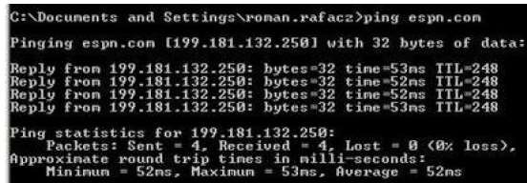

To test a TCP/IP configuration, ping the loopback address by typing ping

127.0.0.1. The results should tell if the connection was successful or if there is any lost packets due to poor network connection or congestion.

1. **ifconfig / ipconfig**

Displays basic current TCP/IP network configuration. It is very useful to troubleshoot networking problems. ipconfig/all is used to provide detailed information such as IP address, subnet mask, MAC address, DNS server, DHCP server, default gateway etc. ipconfig/renew is used to renew a DHCP assigned IP address whereas ipconfig/release is used to discard the assigned DHCP IP address.

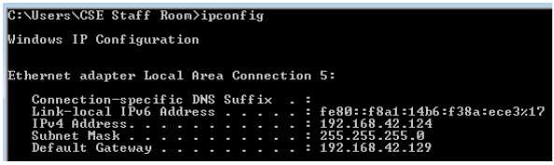

1. **traceroutet / tracert**

Displays the path taken to a destination by sending ICMP Echo Request messages to the destination with TTL field values. The path displayed is the list of nearest router interfaces taken along each hop in the path between source host and destination.

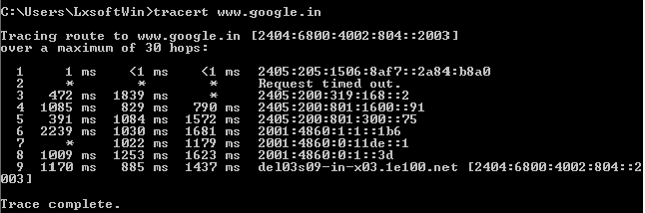

1. **netstat**

Displays active TCP connections, ports on which the computer is listening, Ethernet statistics, IP routing table, IPv4 statistics and IPv6 statistics. It indicates state of a TCP connection. it's a helpful tool in finding problems and determining the amount of traffic on the network as a performance measurement.

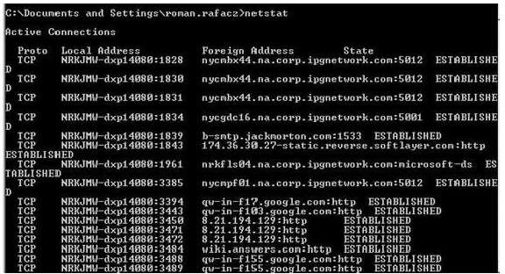

1. **nslookup**

It provides a command-line utility for querying DNS table of a DNS Server. It returns IP address for the given host name.

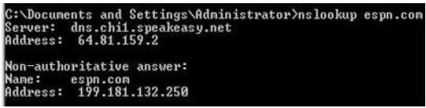

1. **tcpdump**

tcpdump is a most powerful and widely used command-line packets sniffer or package analyzer tool which is used to capture or filter TCP/IP packets that received or transferred over a network on a specific interface for analysis.

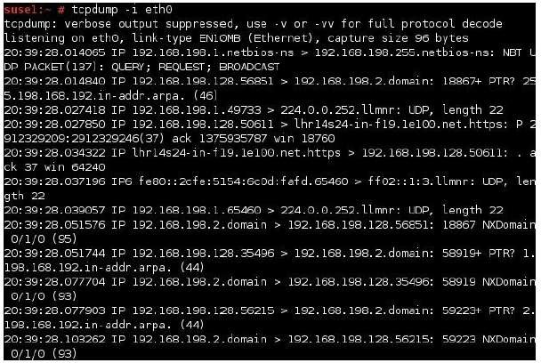

# RESULT:

Thus the TCP/IP network command utilities is studied in detail.

|  |  |
| --- | --- |
| **EX.NO:1 (b)** | **Capture ping and traceroute PDUs using a Network Protocol Analyzer** |
| **DATE:** |

# AIM:

To capture ping and traceroute PDUs using a network protocol analyzer and examine in detail.

**WIRESHARK TOOL**

When Wireshark is launched, the screen below is displayed.

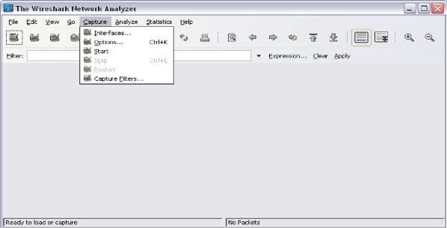

To start data capture it is first necessary to go to the **Capture** menu and select the **Options** choice. The **Options** dialog provides a range of settings and filters which determines which and how much data traffic is captured.

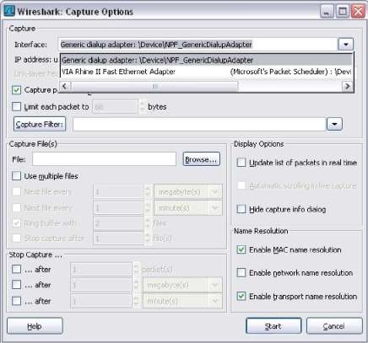

First, it is necessary to ensure that Wireshark is set to monitor the correct interface. From the **Interface** drop-down list, select the network adapter in use. Typically, for a computer this will be the connected Ethernet Adapter.

Then other Options can be set. Among those available in **Capture Options,** the two highlighted below are worth examination.

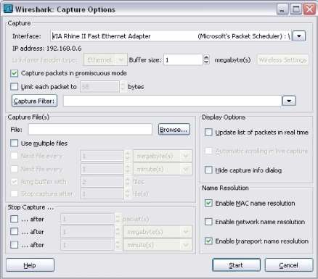

Clicking on the **Start** button starts the data capture process and a message box displays the progress of this process.

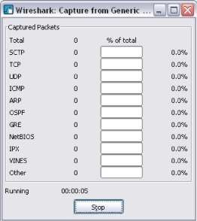

As data PDUs are captured, the types and number are indicated in the message box

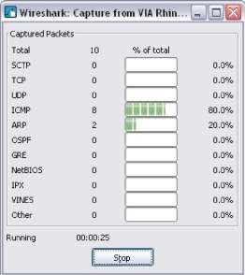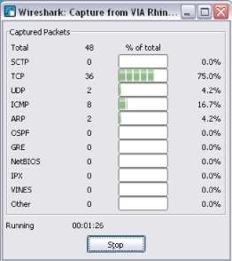

The examples above show the capture of a ping process and then accessing a web page.

When the **Stop** button is clicked, the capture process is terminated and the main screen is displayed.

This main display window of Wireshark has three panes.

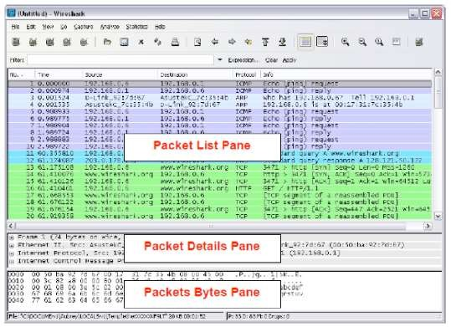

The PDU (or Packet) List Pane at the top of the diagram displays a summary of each packet captured. By clicking on packets in this pane, you control what is displayed in the other two panes. The PDU (or Packet) Details Pane in the middle of the diagram displays the packet selected in the Packet List Pane in more detail.

The PDU (or Packet) Bytes Pane at the bottom of the diagram displays the actual data (in hexadecimal form representing the actual binary) from the packet selected in the Packet List Pane, and highlights the field selected in the Packet Details Pane.

**Task 1: Ping PDU Capture**

Step 1: After ensuring that the standard lab topology and configuration is correct, launch Wireshark on a computer in a lab pod. Set the Capture Options as described above in the overview and start the capture process. From the command line of the computer, ping the IP address of another network connected and powered on end device on in the lab topology. In this case, ping the Eagle Server at using the command ping 192.168.254.254. After receiving the successful replies to the ping in the command line window, stop the packet capture.

Step 2: Examine the Packet List pane.

The Packet List pane on Wireshark should now look something like this:

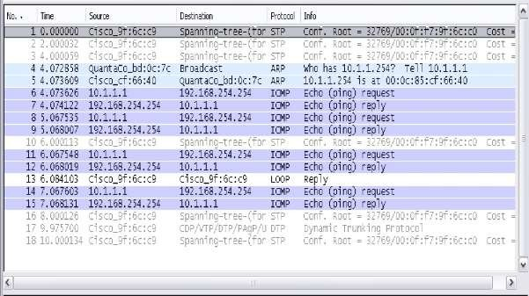

Look at the packets listed above; we are interested in packet numbers 6, 7, 8, 9, 11, 12, 14 and 15. Locate the equivalent packets on the packet list on your computer.

Step 3: Select (highlight) the first echo request packet on the list with the mouse. The Packet Detail pane will now display something similar to: Click on each of the four "+" to expand the information. The packet Detail Pane will now be similar to:

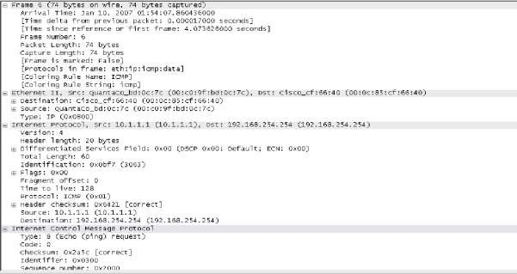

**Task 2: Traceroute PDU Capture**

Traceroute generates a list of each hop by entering IP of routers that traversed between source and destination and average round-trip time. As a result **hop 22 denotes** entry of destination i.e. Google DNS. In order to notice the activity of traceroute, Wireshark runs in the background.

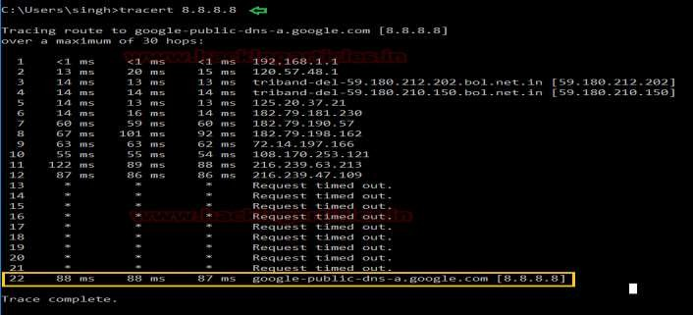

**At Wireshark the following points are notices:**

* ICMP echo request packet is used instead of UDP to send DNS query.
* The packet first goes from source 192.168.1.101 to first router 192.168.1.1 having ICMP echo request packet with TTL=1
* The router will drop that packet and send ICMP Time Exceeded error message to the source.
* All this happens 3 times before the source machine sends next packet by incrementing TTL value by 1 i.e. TTL=2.

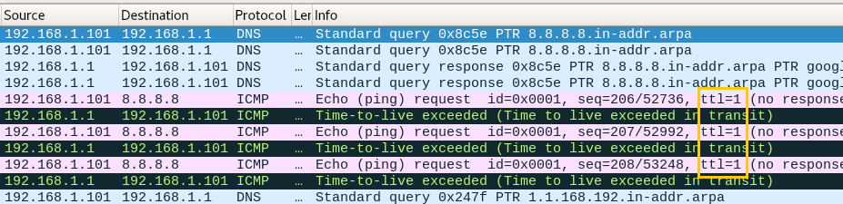

From this image we can observe ICMP echo reply message is sent from 8.8.8.8 (destination) to 192.168.1.101 (source) for TTL 22.

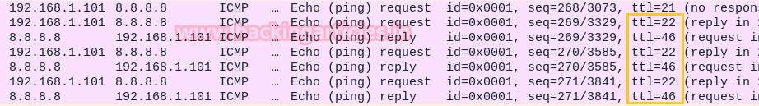

# RESULT:

Thus the capturing of ping and traceroute PDUs using a network protocol analyzer examined.

|  |  |
| --- | --- |
| **EX.NO: 2** | **HTTP Web Client** |
| **DATE:** |

# AIM:

To write a java HTTP web client program to download a web page using

TCP sockets.

# ALGORITHM:

**Step 1:** Start the program.

**Step 2:** Set a server port as 80.

**Step 3:** Using HTTP services create a Socket for server by specifying the server port.

**Step 4:** Use HTTP socket for connecting the client to the URL.

**Step 5:** Use BufferedReader to output stream to place the response from the server by the client.

**Step 6:** Close the Connection as soon the request is been serviced. Use Malformed URL exception If any errors in grabbing the server.

**Step 7:** Stop the program.

# PROGRAM:

import java.io.*; import java.net.*;

public class SocketHTTPClient

{

public static void main(String[] args)

{

String hostName = ["ww](http://www.martinbroadhurst.com/)w[.martinbroadhurst.com](http://www.martinbroadhurst.com/)"; int portNumber = 80;

try

{

true);

Socket socket = new Socket(hostName, portNumber); PrintWriter out = new PrintWriter(socket.getOutputStream(),

BufferedReader in = new BufferedReader(new

InputStreamReader(socket.getInputStream()));

out.println("GET / HTTP/1.1\nHost: www.martinbroadhurst.com\n\n");

String inputLine;

while ((inputLine = in.readLine()) != null)

{

System.out.println(inputLine);

}

}

catch (UnknownHostException e)

{

System.err.println("Don't know about host " + hostName); System.exit(1);

}

catch (IOException e)

{

hostName);

}

}

}

System.err.println("Couldn't get I/O for the connection to " + System.exit(1);

# EXECUTION:

**Step 1:** Save SocketHTTPClient java file as SocketHTTPClient.java.

**Step 2:** Open two cmd prompt.

**Step 3:** Set path for javac compiler and java interpreter in cmd prompt as follows set path=” C:\Program Files\Java\jdk1.7.0_79\bin”;

**Step 4:** Compile your java program as follows javac SocketHTTPClient.java

It generates Bytecode file (or Object file) as SocketHTTPClient.class

**Step 5:** Execute your java program as follows java SocketHTTPClient

# OUTPUT:

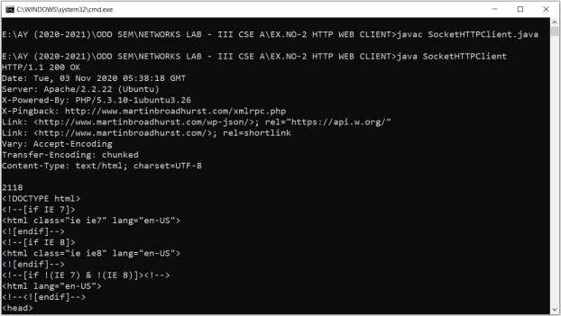

**RESULT:**

Thus the java HTTP web client program to download a web page using TCP sockets has been executed successfully and output got verified.

|  |  |
| --- | --- |
| **EX.NO: 3 (a)** | **Echo client and echo server applications using TCP sockets** |
| **DATE:** |

# AIM:

To write a socket program to implement echo client and echo server

applications using TCP sockets in java.

# ALGORITHM:

**ECHO SERVER:**

**Step 1:** Start the program.

**Step 2:** Import necessary packages to access the predefined classes and its methods.

**Step 3:** Create server side socket using ServerSocket class.

**Step 4:** Accept connection from client by using accept() method.

**Step 5:** Initialize object for DataInputStream class with getInputStream() method of Socket class to receive message from client.

**Step 6:** Initialize object for DataOutputStream class with getOutputStream() method of Socket class to send message to client.

**Step 7:** Using readUTF() method receive message from client.

**Step 8:** Using writeUTF() method to echo received message to client.

**Step 8:** Stop the program.

# ECHO CLIENT:

**Step 1:** Start the program.

**Step 2:** Import necessary packages to access the predefined classes and its methods.

**Step 3:** Create client side socket using Socket class.

**Step 4:** Initialize object for DataInputStream class with getInputStream() method of Socket class to receive message from client.

**Step 5:** Initialize object for DataOutputStream class with getOutputStream() method of Socket class to send message to client.

**Step 6:** Using readUTF() and writeUTF() method send and receive mesaage from server.

**Step 7:** Stop the program.

# PROGRAM: ECHO SERVER:

import java.io.*; import java.net.*; import java.util.*;

public class EchoServer

{

public static void main(String args[])

{

try

{

ServerSocket ss=new ServerSocket(6666); Socket s=ss.accept();

DataInputStream din=new DataInputStream(s.getInputStream()); DataOutputStream dout=new

DataOutputStream(s.getOutputStream());

Scanner input=new Scanner(System.in); String senddata="";

String recievedata=""; while(!recievedata.equals("stop"))

{

recievedata=din.readUTF(); System.out.println("CLIENT SAYS :"+recievedata); dout.writeUTF(recievedata);

}

din.close();

dout.close();

s.close();

ss.close();

}

catch(Exception e)

{

System.out.println(e);

}

}

}

# ECHO CLIENT:

import java.io.*; import java.net.*; import java.util.*; public class EchoClient

{

public static void main(String args[])

{

try

{

Socket s=new Socket("localhost",6666);

DataInputStream din=new DataInputStream(s.getInputStream()); DataOutputStream dout=new

DataOutputStream(s.getOutputStream());

Scanner input=new Scanner(System.in); String senddata="";

String recievedata=""; while(!senddata.equals("stop"))

{

System.out.print("TO SERVER :"); senddata=input.nextLine(); dout.writeUTF(senddata); recievedata=din.readUTF(); System.out.println("SERVER SAYS :"+recievedata);

}

din.close();

dout.close();

s.close();

}

catch(Exception e)

{

System.out.println(e);

}

}

}

# EXECUTION:

**Step 1:** Save Echo Server java file as EchoServer.java and Echo Client java file as EchoClient.java.

**Step 2:** Open two cmd prompt for client and server.

**Step 3:** Set path for javac compiler and java interpreter in cmd prompt as follows set path=” C:\Program Files\Java\jdk1.7.0_79\bin”;

**Step 4:** Compile your server java program as follows javac EchoServer.java

It generates Bytecode file (or Object file) as EchoServer.class

**Step 5:** Compile your client java program as follows javac EchoClient.java

It generates Bytecode file (or Object file) as EchoClient.class

**Step 6:** Execute your server java program as follows java EchoServer

**Step 7:** Execute your client java program as follows java EchoClient

# OUTPUT:

**Echo Client**

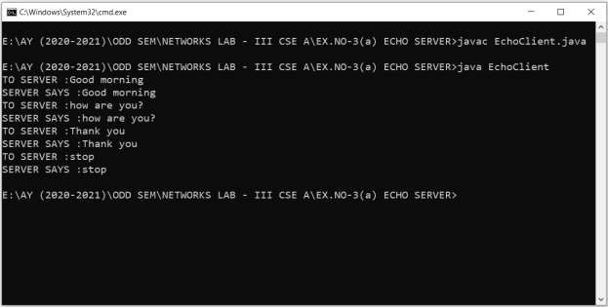

**Echo Server**

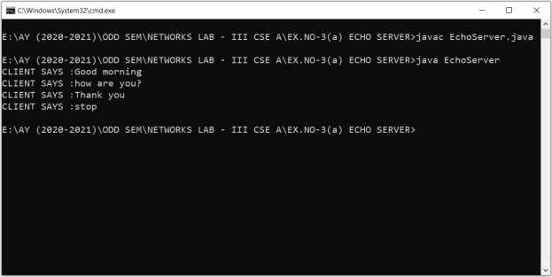

# RESULT:

Thus the socket program to implement echo client and echo server applications using TCP sockets in java has been executed successfully and output got verified.

|  |  |
| --- | --- |
| **EX.NO: 3 (b)** | **Chat Application using TCP Sockets** |
| **DATE:** |

# AIM:

in java.

To write a socket program to implement chat application using TCP sockets

# ALGORITHM:

**CHAT SERVER:**

**Step 1:** Start the program.

**Step 2:** Import necessary packages to access the predefined classes and its methods.

**Step 3:** Create server side socket using ServerSocket class.

**Step 4:** Accept connection from client by using accept() method.

**Step 5:** Initialize object for DataInputStream class with getInputStream() method of Socket class to receive message from client.

**Step 6:** Initialize object for DataOutputStream class with getOutputStream() method of Socket class to send message to client.

**Step 7:** Using readUTF() and writeUTF() method send and receive mesaage between client and server.

**Step 8:** Stop the program.

# CHAT CLIENT:

**Step 1:** Start the program.

**Step 2:** Import necessary packages to access the predefined classes and its methods.

**Step 3:** Create client side socket using Socket class.

**Step 4:** Initialize object for DataInputStream class with getInputStream() method of Socket class to receive message from client.

**Step 5:** Initialize object for DataOutputStream class with getOutputStream() method of Socket class to send message to client.

**Step 6:** Using readUTF() and writeUTF() method send and receive mesaage between client and server.

**Step 7:** Stop the program.

# PROGRAM: CHAT SERVER:

import java.io.*; import java.net.*; import java.util.*; public class ChatServer

{

public static void main(String args[])

{

try

{

ServerSocket ss=new ServerSocket(6666); Socket s=ss.accept();

DataInputStream din=new DataInputStream(s.getInputStream()); DataOutputStream dout=new

DataOutputStream(s.getOutputStream());

Scanner input=new Scanner(System.in); String senddata="";

String recievedata=""; while(!recievedata.equals("stop"))

{

recievedata=din.readUTF(); System.out.println("CLIENT SAYS :"+recievedata); System.out.print("TO CLIENT :"); senddata=input.nextLine(); dout.writeUTF(senddata);

}

din.close();

dout.close();

s.close();

ss.close();

}

catch(Exception e)

{

System.out.println(e);

}

}

}

# CHAT CLIENT:

import java.io.*; import java.net.*; import java.util.*; public class ChatClient

{

public static void main(String args[])

{

try

{

Socket s=new Socket("localhost",6666);

DataInputStream din=new DataInputStream(s.getInputStream()); DataOutputStream dout=new

DataOutputStream(s.getOutputStream());

Scanner input=new Scanner(System.in); String senddata="";

String recievedata=""; while(!senddata.equals("stop"))

{

System.out.print("TO SERVER :"); senddata=input.nextLine(); dout.writeUTF(senddata); recievedata=din.readUTF(); System.out.println("SERVER SAYS :"+recievedata);

}

din.close();

dout.close();

s.close();

}

catch(Exception e)

{

System.out.println(e);

}

}

}

# EXECUTION:

**Step 1:** Save Chat Server java file as ChatServer.java and Chat Client java file as ChatClient.java.

**Step 2:** Open two cmd prompt for client and server.

**Step 3:** Set path for javac compiler and java interpreter in cmd prompt as follows set path=” C:\Program Files\Java\jdk1.7.0_79\bin”;

**Step 4:** Compile your server java program as follows javac ChatServer.java

It generates Bytecode file (or Object file) as ChatServer.class

**Step 5:** Compile your client java program as follows javac ChatClient.java

It generates Bytecode file (or Object file) as ChatClient.class

**Step 6:** Execute your server java program as follows java ChatServer

**Step 7:** Execute your client java program as follows java ChatClient

# OUTPUT:

**Chat Client**

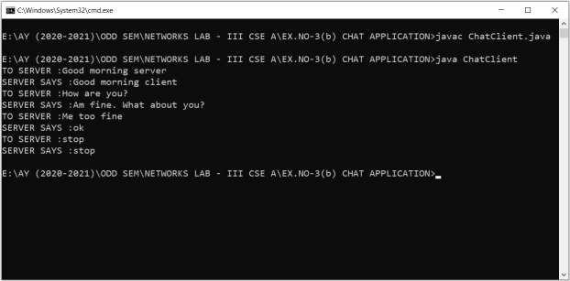

**Chat Server**

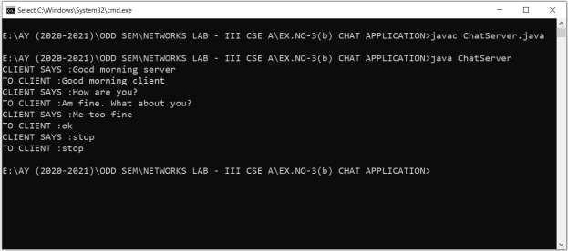

# RESULT:

Thus the socket program to implement chat application using TCP sockets in java has been executed successfully and output got verified.

|  |  |
| --- | --- |
| **EX.NO: 3 (c)** | **File Transfer Application using TCP Sockets** |
| **DATE:** |

# AIM:

To write a socket program to implement file transfer application using TCP

sockets in java.

# ALGORITHM:

**FTP SERVER:**

**Step 1:** Start the program.

**Step 2:** Import necessary packages to access the predefined classes and its methods.

**Step 3:** Create server side socket using ServerSocket class.

**Step 4:** Accept connection from client by using accept() method.

**Step 5:** Initialize PrintStream class object with getOutputStream() method to send content of a file from server to client.

**Step 6:** Using File class select a file to send and use buffer as a internal storage.

**Step 7:** Stop the program.

# FTP CLIENT:

**Step 1:** Start the program.

**Step 2:** Import necessary packages to access the predefined classes and its methods.

**Step 3:** Create client side socket using Socket class.

**Step 4:** Initialize InputStreamReader class object with getInputStream() method to receive content of a file from server.

**Step 5:** Using File class create a file to receive content from server and use buffer as a internal storage.

**Step 6:** Stop the program.

# PROGRAM: FTP SERVER:

import java.io.*; import java.net.*; public class FTPServer

{

public static void main(String args[]) throws Exception

{

ServerSocket ss=new ServerSocket(1024); System.out.println("ServerSocket Generated"); Socket s=ss.accept(); System.out.println("ServerSocket Accepted"); BufferedReader br=new BufferedReader(new

InputStreamReader(System.in));

PrintStream p=new PrintStream(s.getOutputStream()); String fname,str;

System.out.println("Enter a File Name:"); fname=br.readLine();

File f1=new File(fname); if(f1.exists())

{

BufferedReader br1=new BufferedReader(new FileReader(fname));

while((str=br1.readLine())!=null) p.println(str);

}

p.close();

}

}

# FTP CLIENT:

import java.io.*; import java.net.*; public class FTPClient

{

public static void main(String asd[]) throws Exception

{

InetAddress ia=InetAddress.getLocalHost(); Socket s=new Socket(ia,1024);

String fname,str;

System.out.println("Enter a new File Name:"); BufferedReader br=new BufferedReader(new

InputStreamReader(System.in));

fname=br.readLine(); File f1=new File(fname);

PrintWriter p=new PrintWriter(new FileWriter(fname)); BufferedReader br1=new BufferedReader(new

InputStreamReader(s.getInputStream()));

while((str=br1.readLine())!=null) p.println(str);

p.close();

s.close();

}

}

# EXECUTION:

**Step 1:** Save FTP Server java file as FTPServer.java and FTP Client java file as FTPClient.java.

**Step 2:** Open two cmd prompt for client and server.

**Step 3:** Set path for javac compiler and java interpreter in cmd prompt as follows set path=” C:\Program Files\Java\jdk1.7.0_79\bin”;

**Step 4:** Compile your server java program as follows javac FTPServer.java

It generates Bytecode file (or Object file) as FTPServer.class

**Step 5:** Compile your client java program as follows javac FTPClient.java

It generates Bytecode file (or Object file) as FTPClient.class

**Step 6:** Execute your server java program as follows java FTPServer

**Step 7:** Execute your client java program as follows java FTPClient

# OUTPUT:

**FTP Client**

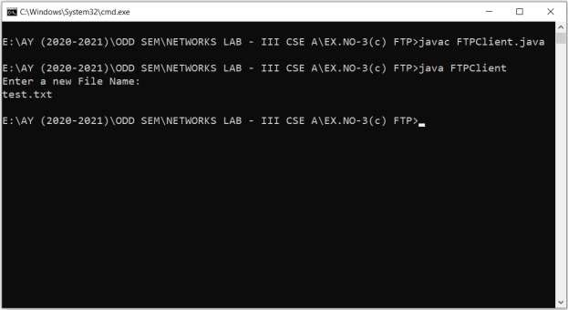

**FTP Server**

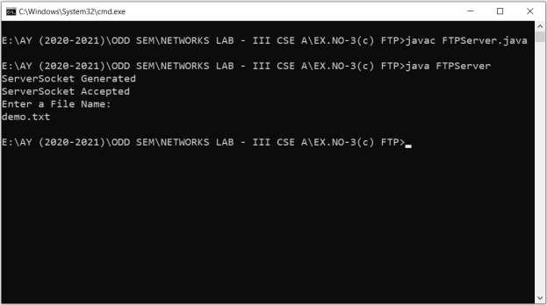

**Client Text File**

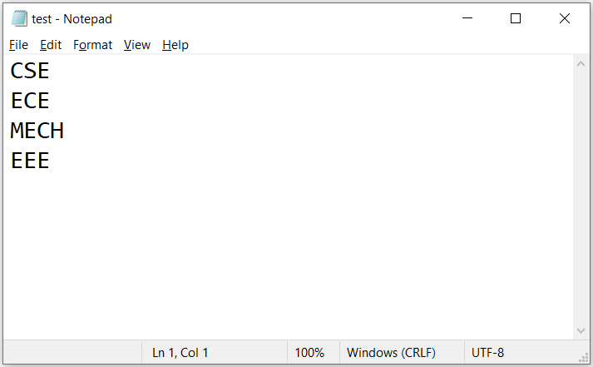

**Server Text File**

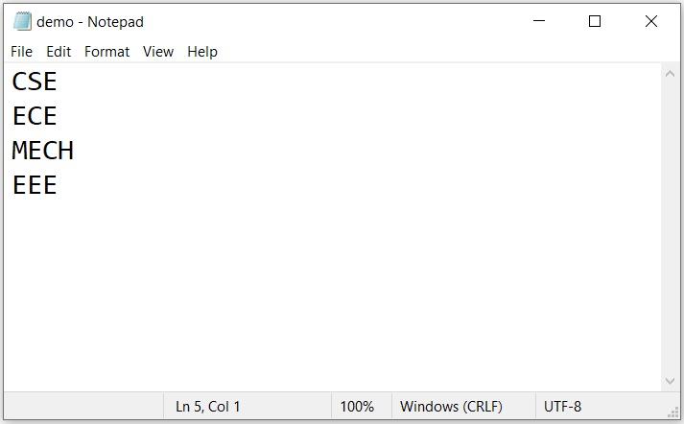

# RESULT:

Thus the socket program to implement file transfer application using TCP sockets in java has been executed successfully and output got verified.

|  |  |
| --- | --- |
| **EX.NO: 4** | **Simulation of DNS using UDP Sockets** |
| **DATE:** |

# AIM:

To write a socket program for simulating DNS using UDP sockets in java.

# ALGORITHM:

**CLIENT**

**Step 1:** Start the program

**Step 2:** Using datagram sockets UDP function is established.

**Step 3:** Get the server name address to be converted into IP address.

**Step 4:** Send this server name to server.

**Step 5:** Server returns the IP address to client.

**Step 6:** Stop the program.

# SERVER

**Step 1:** Start the program

**Step 2:** Accept the socket which is created by the client.

**Step 3:** Server maintains the table in which IP and corresponding server name are stored.

**Step 4:** Read the server name which is send by the client.

**Step 5:** Map the server name with its IP address and return the IP address to client.

**Step 6:** Stop the program.

# PROGRAM:

**SERVER:**

import java.io.*; import java.net.*; import java.util.*; class Server

{

public static void main(String args[])

{

try

{

DatagramSocket server=new DatagramSocket(1309); while(true)

{

byte[] sendbyte=new byte[1024]; byte[] receivebyte=new byte[1024]; DatagramPacket receiver=new

DatagramPacket(receivebyte,receivebyte.length);

server.receive(receiver);

String str=new String(receiver.getData()); String s=str.trim();

//System.out.println(s);

InetAddress addr=receiver.getAddress(); int port=receiver.getPort();

String ip[]={"165.165.80.80","165.165.79.1"};

String name[][={"w](http://www.aptitudeguru.com/)ww[.apt](http://www.aptitudeguru.com/)i[tudeguru.com](http://www.aptitudeguru.com/)[","ww](http://www.downloadcyclone.blogspot.com/)w.d[ownloadcyclone.blogspot.com](http://www.downloadcyclone.blogspot.com/)"};

for(int i=0;i<ip.length;i++)

{

if(s.equals(ip[i]))

{

sendbyte=name[i].getBytes(); DatagramPacket sender=new

DatagramPacket(sendbyte,sendbyte.length,addr,port);

server.send(sender);

break;

}

else if(s.equals(name[i]))

{

sendbyte=ip[i].getBytes(); DatagramPacket sender=new

DatagramPacket(sendbyte,sendbyte.length,addr,port);

server.send(sender); break;

}

}

break;

}

}

catch(Exception e)

{

System.out.println(e);

}

}

}

# CLIENT:

import java.io.*; import java.net.*; import java.util.*; class Client

{

public static void main(String args[])

{

try

{

DatagramSocket client=new DatagramSocket(); InetAddress addr=InetAddress.getByName("127.0.0.1");

byte[] sendbyte=new byte[1024]; byte[] receivebyte=new byte[1024];

BufferedReader in=new BufferedReader(new InputStreamReader(System.in));

System.out.println("Enter the SERVER/DOMAIN NAME:"); String str=in.readLine(); sendbyte=str.getBytes();

DatagramPacket sender=new DatagramPacket(sendbyte,sendbyte.length,addr,1309);

client.send(sender); DatagramPacket receiver=new

DatagramPacket(receivebyte,receivebyte.length);

client.receive(receiver);

String s=new String(receiver.getData()); System.out.println("IP address is: "+s.trim()); client.close();

}

catch(Exception e)

{

System.out.println(e);

}

}

}

# EXECUTION:

**Step 1:** Save Server java file as Server.java and Client java file as Client.java.

**Step 2:** Open two cmd prompt for client and server.

**Step 3:** Set path for javac compiler and java interpreter in cmd prompt as follows set path=” C:\Program Files\Java\jdk1.7.0_79\bin”;

**Step 4:** Compile your server java program as follows javac Server.java

It generates Bytecode file (or Object file) as Server.class

**Step 5:** Compile your client java program as follows javac Client.java

It generates Bytecode file (or Object file) as Client.class

**Step 6:** Execute your server java program as follows java Server

**Step 7:** Execute your client java program as follows java Client

# OUTPUT:

**Client**

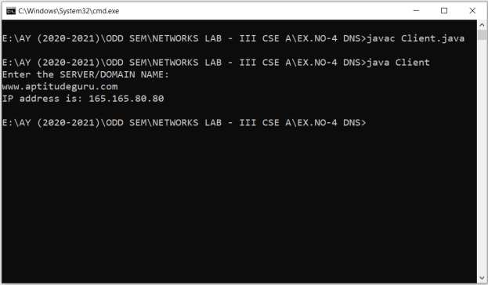

**Server**

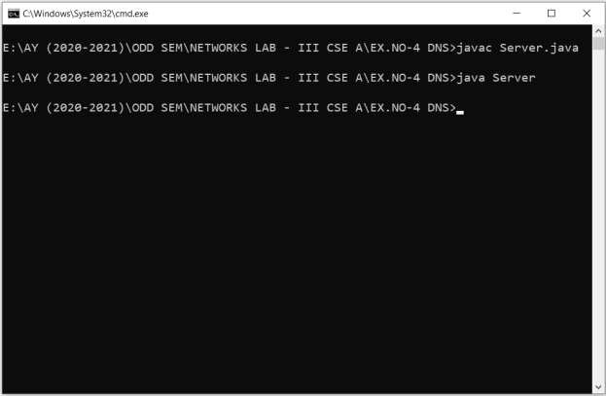

# RESULT:

Thus the socket program for simulating DNS using UDP sockets in java has been executed successfully and output got verified.

|  |  |
| --- | --- |
| **EX.NO: 5 (a)** | **Simulating ARP Protocol** |
| **DATE:** |

# AIM:

in java.

To write a socket program for simulating ARP protocol using TCP sockets

# ALGORITHM:

**CLIENT**

**Step 1:** Start the program

**Step 2:** Using socket connection is established between client and server.

**Step 3:** Get the IP address to be converted into MAC address.

**Step 4:** Send this IP address to server.

**Step 5:** Server returns the MAC address to client.

**Step 6:** Stop the program.

# SERVER

**Step 1:** Start the program

**Step 2:** Accept the socket which is created by the client.

**Step 3:** Server maintains the table in which IP and corresponding MAC addresses are stored.

**Step 4:** Read the IP address which is send by the client.

**Step 5:** Map the IP address with its MAC address and return the MAC address to client.

**Step 6:** Stop the program.

# PROGRAM: SERVER:

import java.io.*; import java.net.*; import java.util.*; class Server

{

public static void main(String args[])

{

try

{

ServerSocket obj=new ServerSocket(3636); Socket obj1=obj.accept();

while(true)

{

DataInputStream din=new DataInputStream(obj1.getInputStream());

DataOutputStream dout=new DataOutputStream(obj1.getOutputStream()); String str=din.readLine();

String ip[]={"165.165.80.80","165.165.79.1"};

String mac[]={"6A:08:AA:C2","8A:BC:E3:FA"};

for(int i=0;i<ip.length;i++)

{

if(str.equals(ip[i]))

{

dout.writeBytes(mac[i]+'\n'); break;

}

}

obj.close();

}

}

catch(Exception e)

{

System.out.println(e);

}

}

}

# CLIENT:

import java.io.*; import java.net.*; import java.util.*; class Client

{

public static void main(String args[])

{

try

{

BufferedReader in=new BufferedReader(new

InputStreamReader(System.in));

Socket clsct=new Socket("127.0.0.1",3636); DataInputStream din=new

DataInputStream(clsct.getInputStream()); DataOutputStream dout=new DataOutputStream(clsct.getOutputStream());

System.out.println("Enter the Logical address(IP):"); String str1=in.readLine(); dout.writeBytes(str1+'\n');

String str=din.readLine();

System.out.println("The Physical Address is: "+str); clsct.close();

}

catch (Exception e)

{

System.out.println(e);

}

}

}

# EXECUTION:

**Step 1:** Save Server java file as Server.java and Client java file as Client.java.

**Step 2:** Open two cmd prompt for client and server.

**Step 3:** Set path for javac compiler and java interpreter in cmd prompt as follows set path=” C:\Program Files\Java\jdk1.7.0_79\bin”;

**Step 4:** Compile your server java program as follows javac Server.java

It generates Bytecode file (or Object file) as Server.class

**Step 5:** Compile your client java program as follows javac Client.java

It generates Bytecode file (or Object file) as Client.class

**Step 6:** Execute your server java program as follows java Server

**Step 7:** Execute your client java program as follows java Client

# OUTPUT:

**Client**

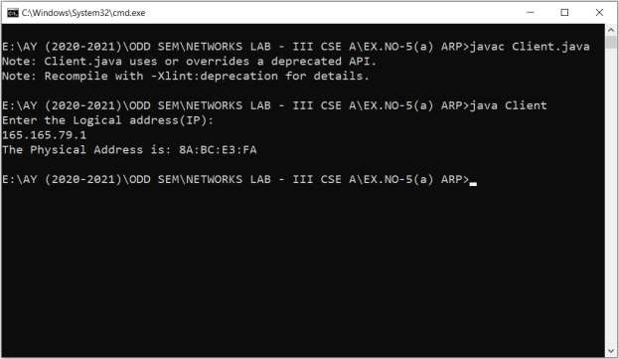

**Server**

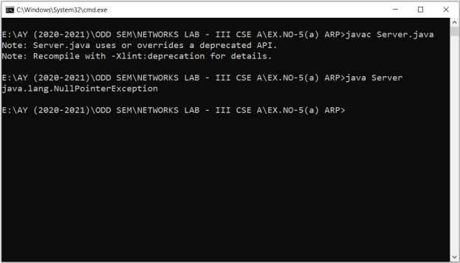

# RESULT:

Thus the socket program for simulating ARP protocol using TCP sockets in java has been executed successfully and output got verified.

|  |  |
| --- | --- |
| **EX.NO: 5 (b)** | **Simulating RARP Protocol** |
| **DATE:** |

# AIM:

in java.

To write a socket program for simulating RARP protocol using TCP sockets

# ALGORITHM:

**CLIENT**

**Step 1:** Start the program.

**Step 2:** Using socket connection is established between client and server.

**Step 3:** Get the MAC address to be converted into IP address.

**Step 4:** Send this MAC address to server. **Step 5:** Server returns the IP address to client. **Step 6:** Stop the program.

# SERVER

**Step 1:** Start the program

**Step 2:** Accept the socket which is created by the client.

**Step 3:** Server maintains the table in which IP and corresponding MAC addresses are stored.

**Step 4:** Read the MAC address which is send by the client.

**Step 5:** Map the IP address with its MAC address and return the IP address to client.

**Step 6:** Stop the program.

# PROGRAM: SERVER:

import java.io.*; import java.net.*; import java.util.*; class Server

{

public static void main(String args[])

{

try

{

ServerSocket obj=new ServerSocket(3000); Socket obj1=obj.accept();

while(true)

{

DataInputStream din=new DataInputStream(obj1.getInputStream());

DataOutputStream dout=new DataOutputStream(obj1.getOutputStream());

String str=din.readLine();

String ip[]={"165.165.80.80","165.165.79.1"};

String mac[]={"6A:08:AA:C2","8A:BC:E3:FA"};

for(int i=0;i<mac.length;i++)

{

if(str.equals(mac[i]))

{

dout.writeBytes(ip[i]+'\n'); break;

}

}

obj.close();

}

}

catch(Exception e)

{

System.out.println(e);

}

}

}

# CLIENT:

import java.io.*; import java.net.*; import java.util.*; class Client

{

public static void main(String args[])

{

try

{

BufferedReader in=new BufferedReader(new InputStreamReader(System.in));

Socket clsct=new Socket("127.0.0.1",3000);

DataInputStream din=new DataInputStream(clsct.getInputStream()); DataOutputStream dout=new

DataOutputStream(clsct.getOutputStream());

System.out.println("Enter the Physical Addres (MAC):"); String str1=in.readLine();

dout.writeBytes(str1+'\n'); String str=din.readLine();

System.out.println("The Logical address is(IP): "+str); clsct.close();

}

catch (Exception e)

{

System.out.println(e);

}

}

}

# EXECUTION:

**Step 1:** Save Server java file as Server.java and Client java file as Client.java.

**Step 2:** Open two cmd prompt for client and server.

**Step 3:** Set path for javac compiler and java interpreter in cmd prompt as follows set path=” C:\Program Files\Java\jdk1.7.0_79\bin”;

**Step 4:** Compile your server java program as follows javac Server.java

It generates Bytecode file (or Object file) as Server.class

**Step 5:** Compile your client java program as follows javac Client.java

It generates Bytecode file (or Object file) as Client.class

**Step 6:** Execute your server java program as follows java Server

**Step 7:** Execute your client java program as follows java Client

# OUTPUT:

**Client**

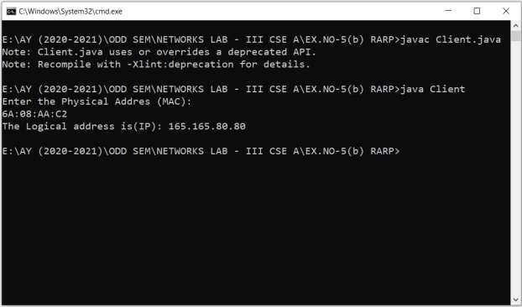

**Server**

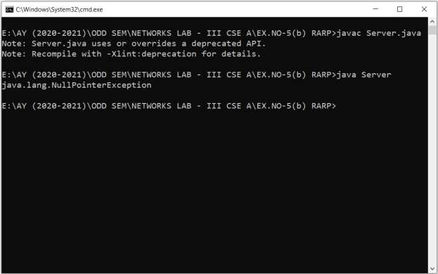

# RESULT:

Thus the socket program for simulating RARP using TCP sockets in java has been executed successfully and output got verified.

|  |  |
| --- | --- |
| **EX.NO: 6 (a)** | **Study of Network Simulator** |
| **DATE:** |

# AIM:

To study about NS2 simulator in detail.

# THEORY:

Network Simulator (Version 2), widely known as NS2, is simply an event driven simulation tool that has proved useful in studying the dynamic nature of communication networks. Simulation of wired as well as wireless network functions and protocols (e.g., routing algorithms, TCP, UDP) can be done using NS2. In general, NS2 provides users with a way of specifying such network protocols and simulating their corresponding behaviors. Due to its flexibility and modular nature, NS2 has gained constant popularity in the networking research community since its birth in 1989. Ever since, several revolutions and revisions have marked the growing maturity of the tool, thanks to substantial contributions from the players in the field. Among these are the University of California and Cornell University who developed the REAL network simulator,1 the foundation which NS is based on. Since 1995 the Defense Advanced Research Projects Agency (DARPA) supported development of NS through the Virtual Inter Network Testbed (VINT) project . Currently the National Science Foundation (NSF) has joined the ride in development. Last but not the least, the group of Researchers and developers in the community are constantly working to keep NS2 strong and versatile.

Figure 2.1 shows the basic architecture of NS2. NS2 provides users with an executable command ns which takes on input argument, the name of a Tcl simulation scripting file. Users are feeding the name of a Tcl simulation script (which sets up a simulation) as an input argument of an NS2 executable command ns.

In most cases, a simulation trace file is created, and is used to plot graph and/or

to create animation. NS2 consists of two key languages: C++ and Object- oriented Tool Command Language (OTcl). While the C++ defines the internal mechanism (i.e., a backend) of the simulation objects, the OTcl sets up simulation by assembling and configuring the objects as well as scheduling discrete events (i.e., a frontend).

# BASIC ARCHITECTURE:

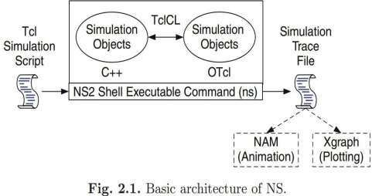

The C++ and the OTcl are linked together using TclCL. Mapped to a C++ object, variables in the OTcl domains are sometimes referred to as handles. Conceptually, a handle (e.g., n as a Node handle) is just a string (e.g.,_o10) in the OTcl domain, and does not contain any functionality. Instead, the functionality (e.g., receiving a packet) is defined in the mapped C++ object (e.g., of class Connector). In the OTcl domain, a handle acts as a frontend which interacts with users and other OTcl.

objects. It may defines its own procedures and variables to facilitate the interaction. Note that the member procedures and variables in the OTcl domain are called instance procedures (instprocs) and instance variables (instvars), respectively. Before proceeding further, the readers are encouraged to learn C++ and OTcl languages. We refer the readers to [14] for the detail of C++, while a brief tutorial of Tcl and OTcl tutorial are given in Appendices A.1 and A.2, respectively.

NS2 provides a large number of built-in C++ objects. It is advisable to use these C++ objects to set up a simulation using a Tcl simulation script. However, advance users

may find these objects insufficient. They need to develop their own C++ objects, and use a OTcl configuration interface to put together these objects. After simulation, NS2 outputs either text-based or animation-based simulation results. To interpret these

results graphically and interactively, tools such as NAM (Network AniMator) and XGraph are used. To analyze a particular behaviour of the network, users can extract a relevant subset of text-based data and transform it to a more conceivable presentation.

# CONCEPT OVERVIEW:

NS uses two languages because simulator has two different kinds of things it needs to do. On one hand, detailed simulations of protocols requires a systems programming language which can efficiently manipulate bytes, packet headers, and implement algorithms that run over large data sets. For these tasks run-time speed is important and turn-around time (run simulation, find bug, fix bug, recompile, re-run) is less important. On the other hand, a large part of network research involves slightly varying parameters or configurations, or quickly exploring a number of scenarios.

In these cases, iteration time (change the model and re-run) is more important. Since configuration runs once (at the beginning of the simulation), run-time of this part of the task is less important. ns meets both of these needs with two languages, C++ and OTcl.

1. **Tcl scripting**

Tcl is a general purpose scripting language. [Interpreter]

* + Tcl runs on most of the platforms such as Unix, Windows, and Mac.
  + The strength of Tcl is its simplicity.
  + It is not necessary to declare a data type for variable prior to the usage.

1. **Basics of TCL**

Syntax: command arg1 arg2 arg3

1. **Hello World!**

puts stdout{Hello, World!} Hello, World!

**Variables** Command Substitution set a 5 set len [string length foobar]

set b $a set len [expr [string length foobar] + 9]

1. **Wired TCL Script Components**

Create the event scheduler Open new files &

turn on the tracing Create the nodes Setup the links

Configure the traffic type (e.g., TCP, UDP, etc) Set the time of traffic generation (e.g., CBR, FTP) Terminate the simulation

1. **NS Simulator Preliminaries.**
2. Initialization and termination aspects of the ns simulator.
3. Definition of network nodes, links, queues and topology.
4. Definition of agents and of applications.
5. The nam visualization tool.
6. Tracing and random variables.
7. **Initialization and Termination of TCL Script in NS-2**

An ns simulation starts with the command

1. **set ns [new Simulator]**

Which is thus the first line in the tcl script. This line declares a new variable as using the set command, you can call this variable as you wish, In general people declares it as ns because it is an instance of the Simulator class, so an object the code[new Simulator] is indeed the installation of the class Simulator using the reserved word new.

In order to have output files with data on the simulation (trace files) or files used for visualization (nam files), we need to create the files using

―open command:

**#Open the Trace file**

**set tracefile1 [open out.tr w]**

**$ns trace-all $tracefile #Open the NAM trace file**

**set namfile [open out.nam w]**

**$ns namtrace-all $namfile**

The above creates a dta trace file called out.tr and a nam visualization trace file called out.nam.

Within the tcl script, these files are not called explicitly by their names, but instead by pointers that are declared above and called ―tracefile1 and ―namfile respectively. Remark that they begins with a # symbol. The second line open the file

―out.tr to be used for writing, declared with the letter ―w. The third line uses a simulator method called trace-all that have as parameter the name of the file where the traces will go.

**Define a “finish‟ procedure Proc finish { } {**

**global ns tracefile1 namfile**

**$ns flush-trace Close $tracefile1 Close $namfile**

**Exec nam out.nam & Exit 0**

**}**

**Definition of a network of links and nodes**

The way to define a node is

1. **set n0 [$ns node]**

Once we define several nodes, we can define the links that connect them. An example of a definition of a link is:

1. **$ns duplex-link $n0 $n2 10Mb 10ms DropTail**

Which means that $n0 and $n2 are connected using a bi-directional link that has 10ms of propagation delay and a capacity of 10Mb per sec for each direction.

To define a directional link instead of a bi-directional one, we should replace

―duplex-link by

―simplex-link.

In ns, an output queue of a node is implemented as a part of each link whose input is that node. We should also define the buffer capacity of the queue related to each link. An example would be:

**#set Queue Size of link (n0-n2) to 20**

**$ns queue-limit $n0 $n2 20**

**FTP over TCP**

TCP is a dynamic reliable congestion control protocol. It uses Acknowledgements created by the destination to know whether packets are well received.

There are number variants of the TCP protocol, such as Tahoe, Reno, NewReno, Vegas. The type of agent appears in the first line:

1. **set tcp [new Agent/TCP]**

The command **$ns attach-agent $n0 $tcp** defines the source node of the tcp connection.

The command **set sink [new Agent /TCPSink]** Defines the behavior of the destination node of TCP and assigns to it a pointer called sink.

**#Setup a UDP connection set udp [new Agent/UDP]**

**$ns attach-agent $n1**

**$udp set null [new Agent/Null]**

**$ns attach-agent $n5 $null**

**$ns connect $udp $null**

**$udp set fid_2**

**#setup a CBR over UDP connection**

**The below shows the definition of a CBR application using a UDP agent**

The command **$ns attach-agent $n4 $sink** defines the destination node. The command **$ns connect**

1. **$tcp $sink finally makes the TCP connection between the source and destination nodes.**

**set cbr [new Application/Traffic/CBR]**

**$cbr attach-agent $udp**

**$cbr set packetsize_ 100**

**$cbr set rate_ 0.01Mb**

**$cbr set random_ false**

TCP has many parameters with initial fixed defaults values that can be changed if mentioned explicitly. For example, the default TCP packet size has a size of 1000bytes.This can be changed to another value, say 552bytes, using the command

**$tcp set packetSize_ 552**.

When we have several flows, we may wish to distinguish them so that we can identify them with different colors in the visualization part. This is done by the command **$tcp set fid_ 1** that assigns to the TCP connection a flow identification of ―1.We shall later give the flow identification of ―2‖ to the UDP connection.

# RESULT:

Thus the network simulator 2 is studied in detail.

|  |  |
| --- | --- |
| **EX.NO: 6 (b)** | **Simulation of Congestion Control Algorithm using NS2** |
| **DATE:** |

# AIM:

NS2.

To simulate a link failure and observe the congestion control algorithm using

# ALGORITHM:

**Step 1:** Create a simulation object **Step 2:** Open the nam trace file **Step 3:** Define a 'finish' procedure **Step 4:** Create eight nodes

**Step 5:** Create links between the nodes

**Step 6:** Create a UDP agent and attach it to node n2,n1,n0

**Step 7:** Create a CBR traffic source and attach it to udp0,udp1,udp2 **Step 8:** Create a Null agent (a traffic sink) and attach it to node n5,n6,n7 **Step 9:** Connect the traffic sources with the traffic sink

**Step 10:** Define different colors for data flows

**Step 11:** Schedule events for the CBR agents

**Step 12:** Call the finish procedure after 5 seconds of simulation time

**Step 13:** Run the simulation

# PROGRAM:

#Create a simulator object set ns [new Simulator]

#Open the nam trace file set nf [open out.nam w]

$ns namtrace-all $nf

#Define a 'finish' procedure proc finish { } {

global ns nf

$ns flush-trace #Close the trace file close $nf

#Execute nam on the trace file exec nam out.nam &

exit 0

}

#Create eight nodes set n0 [$ns node] set n1 [$ns node] set n2 [$ns node] set n3 [$ns node] set n4 [$ns node] set n5 [$ns node] set n6 [$ns node] set n7 [$ns node]

#Create links between the nodes

$ns duplex-link $n0 $n3 1Mb 10ms RED

$ns duplex-link $n1 $n3 1Mb 10ms RED

$ns duplex-link $n2 $n3 1Mb 10ms RED

$ns duplex-link $n3 $n4 1Mb 10ms RED

$ns duplex-link $n4 $n5 1Mb 10ms RED

$ns duplex-link $n4 $n6 1Mb 10ms RED

$ns duplex-link $n4 $n7 1Mb 10ms RED

$ns duplex-link-op $n0 $n3 orient right-up

$ns duplex-link-op $n3 $n4 orient middle

$ns duplex-link-op $n2 $n3 orient right-down

$ns duplex-link-op $n4 $n5 orient right-up

$ns duplex-link-op $n4 $n7 orient right-down

$ns duplex-link-op $n1 $n3 orient right

$ns duplex-link-op $n6 $n4 orient left

#Create a UDP agent and attach it to node n2 set udp0 [new Agent/UDP]

$ns attach-agent $n2 $udp0

#Create a CBR traffic source and attach it to udp0 set cbr0 [new Application/Traffic/CBR]

$cbr0 set packetSize_ 500

$cbr0 set interval_ 0.005

$cbr0 attach-agent $udp0

#Create a Null agent (a traffic sink) and attach it to node n5 set null0 [new Agent/Null]

$ns attach-agent $n5 $null0

#Connect the traffic sources with the traffic sink

$ns connect $udp0 $null0

#Create a UDP agent and attach it to node n1 set udp1 [new Agent/UDP]

$ns attach-agent $n1 $udp1

#Create a CBR traffic source and attach it to udp1 set cbr1 [new Application/Traffic/CBR]

$cbr1 set packetSize_ 500

$cbr1 set interval_ 0.005

$cbr1 attach-agent $udp1

#Create a Null agent (a traffic sink) and attach it to node n6 set null0 [new Agent/Null]

$ns attach-agent $n6 $null0

#Connect the traffic sources with the traffic sink

$ns connect $udp1 $null0

#Create a UDP agent and attach it to node n0 set udp2 [new Agent/UDP]

$ns attach-agent $n0 $udp2

#Create a CBR traffic source and attach it to udp2 set cbr2 [new Application/Traffic/CBR]

$cbr2 set packet size_ 500

$cbr2 set interval_ 0.005

$cbr2 attach-agent $udp2

#Create a Null agent (a traffic sink) and attach it to node n7

set null0 [new Agent/Null]

$ns attach-agent $n7 $null0

#Connect the traffic sources with the traffic sink

$ns connect $udp2 $null0

$udp0 set fid_ 1

$udp1 set fid_ 2

$udp2 set fid_ 3

#Define different colors for data flows

$ns color 1 Red

$ns color 2 Green

$ns color 2 Blue

#Schedule events for the CBR agents

$ns at 0.1 "$cbr0 start"

$ns at 0.2 "$cbr1 start"

$ns at 0.5 "$cbr2 start"

$ns at 4.0 "$cbr2 stop"

$ns at 4.2 "$cbr1 stop"

$ns at 4.5 "$cbr0 stop"

#Call the finish procedure after 5 seconds of simulation time

$ns at 5.0 "finish"

#Run the simulation

$ns run

# OUTPUT:

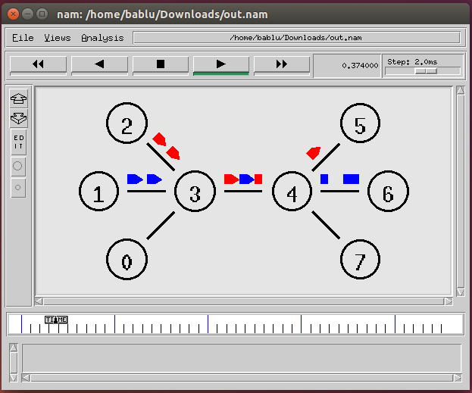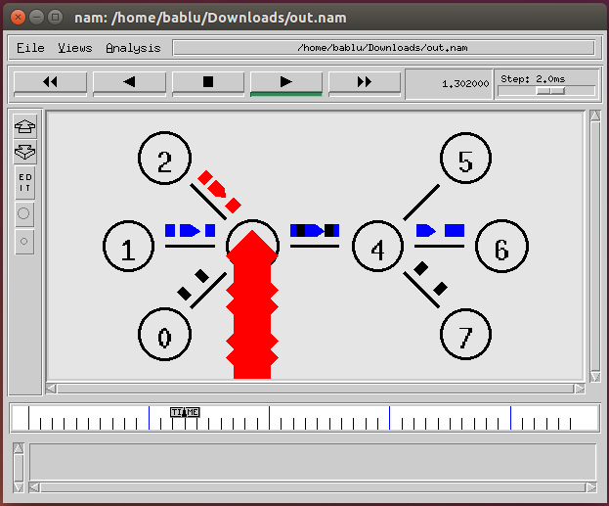

**RESULT:**

Thus the congestion controlling algorithm using ns2 has been executed successfully and output got verified.

|  |  |
| --- | --- |
| **EX.NO: 7 (a)** | **Study of TCP Performance** |
| **DATE:** |

# AIM:

To study about TCP performance in detail.

**Introduction :**

The transmission Control Protocol (TCP) is one of the most important protocols of Internet Protocols suite. It is most widely used protocol for data transmission in communication network such as internet.

**Features**

* TCP is reliable protocol. That is, the receiver always sends either positive or negative acknowledgement about the data packet to the sender, so that the sender always has bright clue about whether the data packet is reached the destination or it needs to resend it.
* TCP ensures that the data reaches intended destination in the same order it was sent.
* TCP is connection oriented. TCP requires that connection between two remote points be established before sending actual data.
* TCP provides error-checking and recovery mechanism.
* TCP provides end-to-end communication.
* TCP provides flow control and quality of service.
* TCP operates in Client/Server point-to-point mode.
* TCP provides full duplex server, i.e. it can perform roles of both receiver and sender.

**Header**

The length of TCP header is minimum 20 bytes long and maximum 60 bytes.

* ***Source port address*.** This is a 16-bit field that defines the port number of the application program in the host that is sending the segment.
* ***Destination port address*.** This is a 16-bit field that defines the port number of the application program in the host that is receiving the segment.

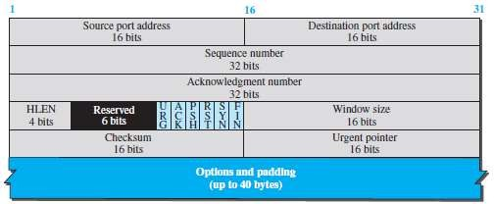

* ***Source port address*.** This is a 16-bit field that defines the port number of the
* application program in the host that is sending the segment.
* ***Destination port address*.** This is a 16-bit field that defines the port number of the application program in the host that is receiving the segment.
* ***Sequence number.*** This 32-bit field defines the number assigned to the first byte of data contained in this segment. TCP is a stream transport protocol. To ensure connectivity, each byte to be transmitted is numbered. The sequence number tells the destination which byte in this sequence is the first byte in the segment. During connection establishment each party uses a random number generator to create an **initial sequence number** (ISN), which is usually different in each direction.
* ***Acknowledgment number.*** This 32-bit field defines the byte number that the receiver of the segment is expecting to receive from the other party. If the receiver of the segment has successfully received byte number *x* from the other party, it returns *x* + 1 as the acknowledgment number. Acknowledgment and data can be piggybacked together.
* ***Header length.*** This 4-bit field indicates the number of 4-byte words in the TCP header. The length of the header can be between 20 and 60 bytes. Therefore, the value of this field is always between 5 (5 × 4 = 20) and 15 (15 ×

4 = 60).

* ***Control.*** This field defines 6 different control bits or flags. One or more of these bits can be set at a time. These bits enable flow control, connection establishment and termination, connection abortion, and the mode of data transfer in TCP.
* ***Window size.*** This field defines the window size of the sending TCP in bytes. Note that the length of this field is 16 bits, which means that the maximum size of the window is 65,535 bytes. This value is normally referred to as the receiving window (*rwnd*) and is determined by the receiver. The sender must obey the dictation of the receiver in this case.
* ***Checksum.*** This 16-bit field contains the checksum. The calculation of the checksum for TCP follows the same procedure as the one described for UDP. However, the use of the checksum in the UDP datagram is optional, whereas
* the use of the checksum for TCP is mandatory. The same pseudoheader, serving the same purpose, is added to the segment. For the TCP pseudoheader, the value for the protocol field is 6.
* ***Urgent pointer.*** This 16-bit field, which is valid only if the urgent flag is set, is used when the segment contains urgent data. It defines a value that must be added to the sequence number to obtain the number of the last urgent byte in the data section of the segment.
* ***Options.*** There can be up to 40 bytes of optional information in the TCP header.

**Addressing**

TCP communication between two remote hosts is done by means of port numbers (TSAPs). Ports numbers can range from 0 – 65535 which are divided as:

* System Ports (0 – 1023)
* User Ports ( 1024 – 49151)
* Private/Dynamic Ports (49152 – 65535)

**Connection Management**

TCP communication works in Server/Client model. The client initiates the connection and the server either accepts or rejects it. Three-way handshaking is used for connection management.

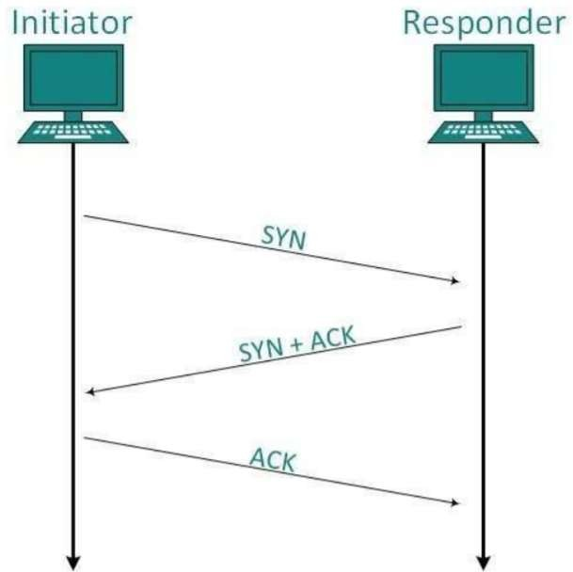

**Establishment**

Client initiates the connection and sends the segment with a Sequence number. Server acknowledges it back with its own Sequence number and ACK of client’s segment which is one more than client’s Sequence number. Client after receiving ACK of its segment sends an acknowledgement of Server’s response.

**Release**

Either of server and client can send TCP segment with FIN flag set to 1. When the receiving end responds it back by Acknowledging FIN, that direction of TCP communication is closed and connection is released.

**Bandwidth Management**

TCP uses the concept of window size to accommodate the need of Bandwidth management. Window size tells the sender at the remote end, the number of data byte segments the receiver at this end can receive. TCP uses slow start phase by using window size 1 and increases the window size exponentially after each successful communication.

For example, the client uses windows size 2 and sends 2 bytes of data. When the acknowledgement of this segment received the windows size is doubled to 4 and next sent the segment sent will be 4 data bytes long. When the acknowledgement of 4-byte data segment is received, the client sets windows size to 8 and so on.

If an acknowledgement is missed, i.e. data lost in transit network or it received NACK, then the window size is reduced to half and slow start phase starts again.

**Error Control &and Flow Control**

TCP uses port numbers to know what application process it needs to handover the data segment. Along with that, it uses sequence numbers to synchronize itself with the remote host. All data segments are sent and received with sequence numbers. The Sender knows which last data segment was received by the Receiver when it gets ACK. The Receiver knows about the last segment sent by the Sender by referring to the sequence number of recently received packet.

If the sequence number of a segment recently received does not match with the sequence number the receiver was expecting, then it is discarded and NACK is sent back. If two segments arrive with the same sequence number, the TCP timestamp value is compared to make a decision.

**Multiplexing**

The technique to combine two or more data streams in one session is called Multiplexing. When a TCP client initializes a connection with Server, it always refers to a welldefined port number which indicates the application process. The client itself uses a randomly generated port number from private port number pools.

Using TCP Multiplexing, a client can communicate with a number of different application process in a single session. For example, a client requests a web page which in turn contains different types of data (HTTP, SMTP, FTP etc.) the TCP session timeout is increased and the session is kept open for longer time so that the three-way handshake overhead can be avoided.

This enables the client system to receive multiple connection over single virtual connection. These virtual connections are not good for Servers if the timeout is too long.

**Congestion Control**

When large amount of data is fed to system which is not capable of handling it, congestion occurs. TCP controls congestion by means of Window mechanism. TCP sets a window size telling the other end how much data segment to send. TCP may use three algorithms for congestion control:

* Additive increase, Multiplicative Decrease
* Slow Start
* Timeout React

**Timer Management**

TCP uses different types of timer to control and management various tasks:

**Keep-alive timer:**

* This timer is used to check the integrity and validity of a connection.
* When keep-alive time expires, the host sends a probe to check if the connection still exists.

**Retransmission timer:**

* This timer maintains stateful session of data sent.
* If the acknowledgement of sent data does not receive within the Retransmission time, the data segment is sent again.

**Persist timer:**

* TCP session can be paused by either host by sending Window Size 0.
* To resume the session a host needs to send Window Size with some larger value. • If this segment never reaches the other end, both ends may wait for each other for infinite time.
* When the Persist timer expires, the host re-sends its window size to let the other end know.
* Persist Timer helps avoid deadlocks in communication.

**Timed-Wait:**

* After releasing a connection, either of the hosts waits for a Timed-Wait time to terminate the connection completely.
* This is in order to make sure that the other end has received the acknowledgement of its connection termination request.
* Timed-out can be a maximum of 240 seconds (4 minutes).

**Crash Recovery**

TCP is very reliable protocol. It provides sequence number to each of byte sent in segment. It provides the feedback mechanism i.e. when a host receives a packet, it is bound to ACK that packet having the next sequence number expected (if it is not the last segment).

When a TCP Server crashes mid-way communication and re-starts its process it sends TPDU broadcast to all its hosts. The hosts can then send the last data segment which was never unacknowledged and carry onwards.

**Algorithm**

1. Create a simulator object
2. Define different flows for data flows
3. Trace all events in a nam file and text file
4. Create source nodes (s1, s2, s3), gateway (G) and receiver (r)
5. Describe their layout topology
6. Specify the link between nodes
7. Define the queue size between nodes G and r as 5
8. Monitor queue on all links vertically 90°
9. Create TCP agents tcp1, tcp2, tcp3 and attach it to nodes s1, s2 and s3 respectively
10. Create three TCP sinks and attach it to node r
11. Connect traffic sources to the sink
12. Create FTP agents ftp1, ftp2, ftp3 and attach it to tcp1, tcp2 and tcp3 respectively
13. Label the nodes at start time
14. Schedule ftp1, ftp2, ftp3 to start at 0.1 and stop at 5.0 seconds
15. Call finish procedure at 5.25 seconds
16. Run the simulation
17. Execute NAM on the trace file
18. Observe the simulated events on the NAM editor and packet flow on link G to r
19. View the trace file and analyse the events
20. Stop

**PROGRAM : File name - TCP.tcl**

#Create a simulator object set ns [new Simulator]

#Open trace files

set f [open droptail-queue-out.tr w]

$ns trace-all $f

#Open the nam trace file

set nf [open droptail-queue-out.nam w]

$ns namtrace-all $nf

#s1, s2 and s3 act as sources. set s1 [$ns node]

set s2 [$ns node] set s3 [$ns node]

#G acts as a gateway set G [$ns node]

#r acts as a receiver set r [$ns node]

#Define different colors for data flows

$ns color 1 red

$ns color 2 SeaGreen

$ns color 3 blue

#Create links between the nodes

$ns duplex-link $s1 $G 6Mb 10ms DropTail

$ns duplex-link $s2 $G 6Mb 10ms DropTail

$ns duplex-link $s3 $G 6Mb 10ms DropTail

$ns duplex-link $G $r 3Mb 10ms DropTail

#Define the layout of the nodes

$ns duplex-link-op $s1 $G orient right-up

$ns duplex-link-op $s2 $G orient right

$ns duplex-link-op $s3 $G orient right-down

$ns duplex-link-op $G $r orient right

#Define the queue size for the link between node G and r

$ns queue-limit $G $r 5

#Monitor the queues for links vertically

$ns duplex-link-op $s1 $G queuePos 0.5

$ns duplex-link-op $s2 $G queuePos 0.5

$ns duplex-link-op $s3 $G queuePos 0.5

$ns duplex-link-op $G $r queuePos 0.5

#Create a TCP agent and attach it to node s1 set tcp1 [new Agent/TCP/Reno]

$ns attach-agent $s1 $tcp1

$tcp1 set window_ 8

$tcp1 set fid_ 1

#Create a TCP agent and attach it to node s2 set tcp2 [new Agent/TCP/Reno]

$ns attach-agent $s2 $tcp2

$tcp2 set window_ 8

$tcp2 set fid_ 2

#Create a TCP agent and attach it to node s3 set tcp3 [new Agent/TCP/Reno]

$ns attach-agent $s3 $tcp3

$tcp3 set window_ 4

$tcp3 set fid_ 3

#Create TCP sink agents and attach them to node r set sink1 [new Agent/TCPSink]

set sink2 [new Agent/TCPSink] set sink3 [new Agent/TCPSink]

$ns attach-agent $r $sink1

$ns attach-agent $r $sink2

$ns attach-agent $r $sink3

#Connect the traffic sources with the traffic sinks

$ns connect $tcp1 $sink1

$ns connect $tcp2 $sink2

$ns connect $tcp3 $sink3

#Create FTP applications and attach them to agents set ftp1 [new Application/FTP]

$ftp1 attach-agent $tcp1

set ftp2 [new Application/FTP]

$ftp2 attach-agent $tcp2

set ftp3 [new Application/FTP]

$ftp3 attach-agent $tcp3

#Define a 'finish' procedure proc finish {} {

global ns

$ns flush-trace

puts "running nam..."

exec nam -a droptail-queue-out.nam & exit 0

}

#Define label for nodes

$ns at 0.0 "$s1 label Sender1"

$ns at 0.0 "$s2 label Sender2"

$ns at 0.0 "$s3 label Sender3"

$ns at 0.0 "$G label Gateway"

$ns at 0.0 "$r label Receiver"

#Schedule ftp events

$ns at 0.1 "$ftp1 start"

$ns at 0.1 "$ftp2 start"

$ns at 0.1 "$ftp3 start"

$ns at 5.0 "$ftp1 stop"

$ns at 5.0 "$ftp2 stop"

$ns at 5.0 "$ftp3 stop"

#Call finish procedure after 5 seconds of simulation time

$ns at 5.25 "finish"

#Run the simulation

$ns run

# OUTPUT:

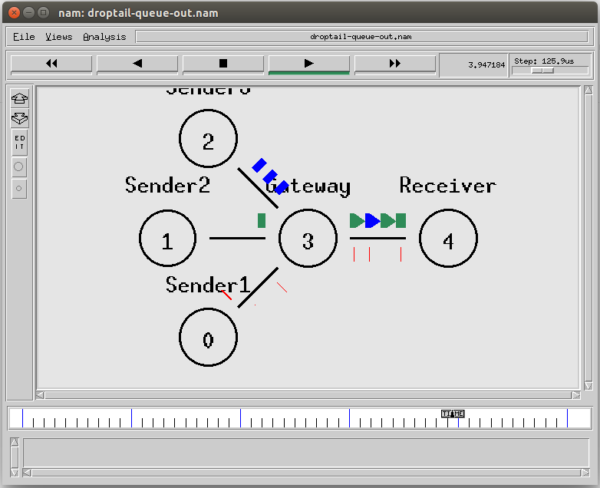

**RESULT:**

Thus the TCP performance is studied in detail.

|  |  |
| --- | --- |
| **EX.NO: 7 (b)** | **Study of UDP Performance** |
| **DATE:** |

# AIM:

To study about UDP performance in detail.

**Introduction :**

The User Datagram Protocol (UDP) is simplest Transport Layer communication protocol available of the TCP/IP protocol suite. It involves minimum amount of communication mechanism. UDP is said to be an unreliable transport protocol but it uses IP services which provides best effort delivery mechanism.

In UDP, the receiver does not generate an acknowledgement of packet received and in turn, the sender does not wait for any acknowledgement of packet sent. This shortcoming makes this protocol unreliable as well as easier on processing.

**Requirement of UDP**

A question may arise, why do we need an unreliable protocol to transport the data? We deploy UDP where the acknowledgement packets share significant amount of bandwidth along with the actual data. For example, in case of video streaming, thousands of packets are forwarded towards its users. Acknowledging all the packets is troublesome and may contain huge amount of bandwidth wastage. The best delivery mechanism of underlying IP protocol ensures best efforts to deliver its packets, but even if some packets in video streaming get lost, the impact is not calamitous and can be ignored easily. Loss of few packets in video and voice traffic sometimes goes unnoticed.

**Features**

* UDP is used when acknowledgement of data does not hold any significance.
* UDP is good protocol for data flowing in one direction.
* UDP is simple and suitable for query based communications.
* UDP is not connection oriented.
* UDP does not provide congestion control mechanism.
* UDP does not guarantee ordered delivery of data.
* UDP is stateless.
* UDP is suitable protocol for streaming applications such as VoIP, multimedia streaming.

**UDP Header**

UDP header is as simple as its function.

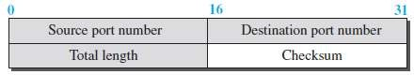

UDP header contains four main parameters:

* **Source Port** - This 16 bits information is used to identify the source port of the packet.
* **Destination Port** - This 16 bits information, is used identify application level service on destination machine.
* **Length -** Length field specifies the entire length of UDP packet (including header). It is 16-bits field and minimum value is 8-byte, i.e. the size of UDP header itself.
* **Checksum** - This field stores the checksum value generated by the sender before sending. IPv4 has this field as optional so when checksum field does not contain any value it is made 0 and all its bits are set to zero.

**UDP application**

Here are few applications where UDP is used to transmit data:

* Domain Name Services
* Simple Network Management Protocol
* Trivial File Transfer Protocol
* Routing Information Protocol
* Kerberos

**Algorithm**

1. Create a simulator object
2. Define different color for data flows
3. Trace all events in a nam file.
4. Create four nodes n0, n1, n2 and n3
5. Describe their layout topology
6. Specify the link capacity between nodes
7. Monitor queue on the link n2 to n3 vertically 90°
8. Create a UDP agents udp0, udp1 and attach it to nodes n0 and n1 respectively
9. Create a CBR traffic cbr0, cbr1 and attach it to udp0 and udp1 respectively
10. Create a traffic sink and attach it to node n3
11. Connect sources to the sink
12. Label the nodes
13. Schedule cbr0 to start at 0.5 and stop at 4.5 seconds
14. Schedule cbr1 to start at 1.0 and stop at 4.0 seconds
15. Call finish procedure at 5.0 seconds
16. Run the simulation
17. Execute NAM on the trace file
18. Observe simulated events on the NAM and packet flow on link n2 to n3
19. Stop

**PROGRAM : File name - UDP.tcl**

#Create a simulator object set ns [new Simulator]

#Define different colors for data flows

$ns color 1 Blue

$ns color 2 Red

#Open the nam trace file set nf [open out.nam w]

$ns namtrace-all $nf

#Create four nodes set n0 [$ns node] set n1 [$ns node] set n2 [$ns node] set n3 [$ns node]

#Create links between the nodes

$ns duplex-link $n0 $n2 1Mb 10ms DropTail

$ns duplex-link $n1 $n2 1Mb 10ms DropTail

$ns duplex-link $n3 $n2 1Mb 10ms SFQ

#Specify layout of nodes

$ns duplex-link-op $n0 $n2 orient right-down

$ns duplex-link-op $n1 $n2 orient right-up

$ns duplex-link-op $n2 $n3 orient right

#Monitor the queue for the link 2ņ3 vertically

$ns duplex-link-op $n2 $n3 queuePos 0.5

#Create a UDP agent and attach it to node n0 set udp0 [new Agent/UDP]

$udp0 set class_ 1

$ns attach-agent $n0 $udp0

# Create a CBR traffic source and attach it to udp0 set cbr0 [new Application/Traffic/CBR]

$cbr0 set packetSize_ 500

$cbr0 set interval_ 0.005

$cbr0 attach-agent $udp0

#Create a UDP agent and attach it to node n1 set udp1 [new Agent/UDP]

$udp1 set class_ 2

$ns attach-agent $n1 $udp1

# Create a CBR traffic source and attach it to udp1 set cbr1 [new Application/Traffic/CBR]

$cbr1 set packetSize_ 500

$cbr1 set interval_ 0.005

$cbr1 attach-agent $udp1

#Create a Null agent (a traffic sink) and attach it to node n3 set null0 [new Agent/Null]

$ns attach-agent $n3 $null0

#Connect traffic sources with the traffic sink

$ns connect $udp0 $null0

$ns connect $udp1 $null0

#Define finish procedure proc finish {} {

global ns nf

$ns flush-trace #Close the trace file close $nf

#Execute nam on the trace file exec nam -a out.nam &

exit 0

}

#Define label for nodes

$ns at 0.0 "$n0 label Sender1"

$ns at 0.0 "$n1 label Sender2"

$ns at 0.0 "$n2 label Router"

$ns at 0.0 "$n3 label Receiver"

#Schedule events for the CBR agents

$ns at 0.5 "$cbr0 start"

$ns at 1.0 "$cbr1 start"

$ns at 4.0 "$cbr1 stop"

$ns at 4.5 "$cbr0 stop"

#Call finish procedure after 5 seconds of simulation time

$ns at 5.0 "finish"

#Run the simulation

$ns run

# OUTPUT:

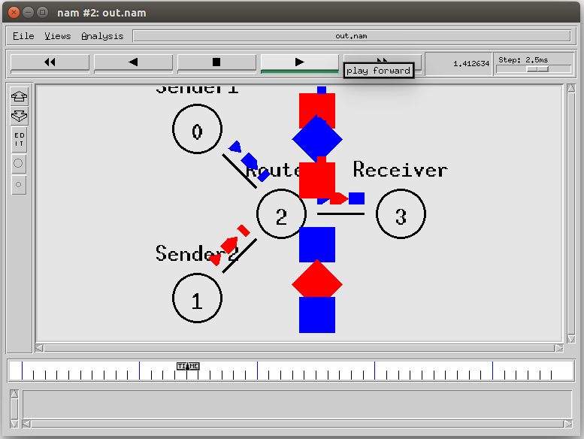

**RESULT:**

Thus the UDP performance is studied in detail.

|  |  |
| --- | --- |
| **EX.NO: 8 (a)** | **Simulation of Distance Vector Routing Algorithm** |
| **DATE:** |

# AIM:

To simulate and observe traffic route of a network using distance vector routing

protocol.

# ALGORITHM:

**Step 1:** Create a simulator object

**Step 2:** Set routing protocol to Distance vector routing

**Step 3:** Trace packets on all links on to NAM trace and text trace file. **Step 4:** Define finish procedure to close files, flash tracing and run NAM **Step 5:** Create 5 nodes

**Step 6:** Specify the link characteristics between the nodes

**Step 7:** Describer their layout topology as a octagon

**Step 8:** Add UDP agent for node n0

**Step 9:** Create CBR traffic on the top of UDP and set traffic parameters

**Step 10:** Add NULL agent to node n3 **Step 11:** Connect source and sink **Step 12:** Schedule as follows

* Start traffic flow at 1.0
* Down the link n1 – n2 at 15.0
* Up the link n1 – n2 at 25.0
* Call finish procedure at 35.0

**Step 13:** Start the scheduler

**Step 14:** Observe the traffic route when the link is up and down **Step 15:** View the simulated events and trace file analyze it **Step 16:** Stop.

# PROGRAM:

#Create a simulator object set ns [new Simulator]

#Use distance vector routing

$ns rtproto DV

#Open the nam trace file set nf [open out.nam w]

$ns namtrace-all $nf

# Open tracefile

set nt [open trace.tr w]

$ns trace-all $nt

#Define 'finish' procedure proc finish {} {

global ns nf

$ns flush-trace #Close the trace file close $nf

#Execute nam on the trace file exec nam -a out.nam &

exit 0

}

# Create 8 nodes set n1 [$ns node] set n2 [$ns node] set n3 [$ns node] set n4 [$ns node] set n5 [$ns node] set n6 [$ns node] set n7 [$ns node] set n8 [$ns node]

# Specify link characterestics

$ns duplex-link $n1 $n2 1Mb 10ms DropTail

$ns duplex-link $n2 $n3 1Mb 10ms DropTail

$ns duplex-link $n3 $n4 1Mb 10ms DropTail

$ns duplex-link $n4 $n5 1Mb 10ms DropTail

$ns duplex-link $n5 $n6 1Mb 10ms DropTail

$ns duplex-link $n6 $n7 1Mb 10ms DropTail

$ns duplex-link $n7 $n8 1Mb 10ms DropTail

$ns duplex-link $n8 $n1 1Mb 10ms DropTail

# specify layout as a octagon

$ns duplex-link-op $n1 $n2 orient left-up

$ns duplex-link-op $n2 $n3 orient up

$ns duplex-link-op $n3 $n4 orient right-up

$ns duplex-link-op $n4 $n5 orient right

$ns duplex-link-op $n5 $n6 orient right-down

$ns duplex-link-op $n6 $n7 orient down

$ns duplex-link-op $n7 $n8 orient left-down

$ns duplex-link-op $n8 $n1 orient left

#Create a UDP agent and attach it to node n1

set udp0 [new Agent/UDP]

$ns attach-agent $n1 $udp0

#Create a CBR traffic source and attach it to udp0 set cbr0 [new Application/Traffic/CBR]

$cbr0 set packetSize_ 500

$cbr0 set interval_ 0.005

$cbr0 attach-agent $udp0

#Create a Null agent (a traffic sink) and attach it to node n4 set null0 [new Agent/Null]

$ns attach-agent $n4 $null0

#Connect the traffic source with the traffic sink

$ns connect $udp0 $null0

#Schedule events for the CBR agent and the network dynamics

$ns at 0.0 "$n1 label Source"

$ns at 0.0 "$n4 label Destination"

$ns at 0.5 "$cbr0 start"

$ns rtmodel-at 1.0 down $n3 $n4

$ns rtmodel-at 2.0 up $n3 $n4

$ns at 4.5 "$cbr0 stop"

#Call the finish procedure after 5 seconds of simulation time

$ns at 5.0 "finish"

#Run the simulation

$ns run

# OUTPUT:

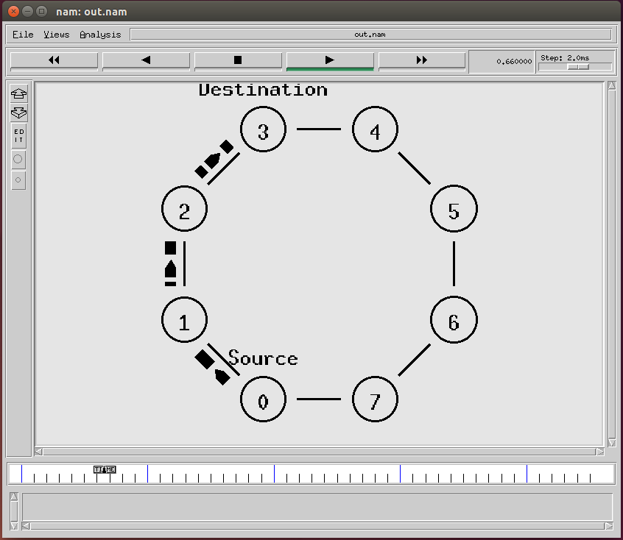

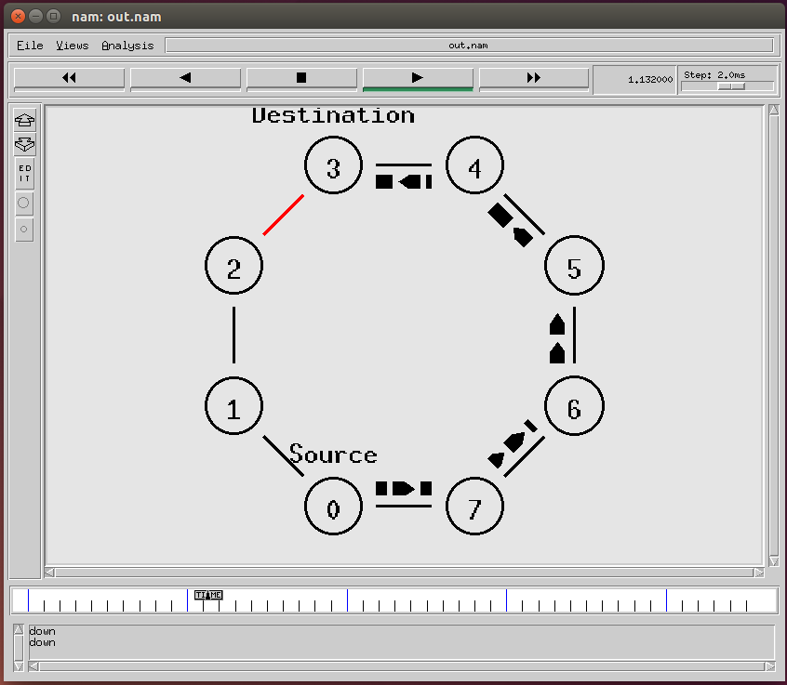

**RESULT:**

Thus the simulation of distance vector routing algorithm using ns2 has been executed successfully and output got verified.

|  |  |
| --- | --- |
| **EX.NO: 8 (b)** | **Simulation of Link State Routing Algorithm** |
| **DATE:** |

# AIM:

To simulate and observe traffic route of a network using link state routing

algorithm.

# ALGORITHM:

**Step 1:** Create a simulator object

**Step 2:** Trace packets on all links on to NAM trace and text trace file. **Step 3:** Define finish procedure to close files, flash tracing and run NAM **Step 4:** Create 5 nodes

**Step 5:** Specify the link characteristics between the nodes

**Step 6:** Describer their layout topology as a octagon

**Step 7:** Add UDP agent for node n0

**Step 8:** Create CBR traffic on the top of UDP and set traffic parameters

**Step 9:** Add NULL agent to node n3

**Step 10:** Connect source and sink

**Step 11:** Set routing protocol to Distance vector routing

**Step 12:** Start the scheduler

**Step 13:** Observe the traffic route when the link is up and down **Step 14:** View the simulated events and trace file analyze it **Step 15:** Stop.

# PROGRAM:

set ns [new Simulator] set nr [open thro.tr w]

$ns trace-all $nr

set nf [open thro.nam w]

$ns namtrace-all $nf proc finish { } { global ns nr nf

$ns flush-trace close $nf close $nr

exec nam thro.nam & exit 0

}

for { set i 0 } { $i < 12} { incr i 1 } { set n($i) [$ns node]}

for {set i 0} {$i < 8} {incr i} {

$ns duplex-link $n($i) $n([expr $i+1]) 1Mb 10ms DropTail }

$ns duplex-link $n(0) $n(8) 1Mb 10ms DropTail

$ns duplex-link $n(1) $n(10) 1Mb 10ms DropTail

$ns duplex-link $n(0) $n(9) 1Mb 10ms DropTail

$ns duplex-link $n(9) $n(11) 1Mb 10ms DropTail

$ns duplex-link $n(10) $n(11) 1Mb 10ms DropTail

$ns duplex-link $n(11) $n(5) 1Mb 10ms DropTail

set udp0 [new Agent/UDP]

$ns attach-agent $n(0) $udp0

set cbr0 [new Application/Traffic/CBR]

$cbr0 set packetSize_ 500

$cbr0 set interval_ 0.005

$cbr0 attach-agent $udp0 set null0 [new Agent/Null]

$ns attach-agent $n(5) $null0

$ns connect $udp0 $null0

set udp1 [new Agent/UDP]

$ns attach-agent $n(1) $udp1

set cbr1 [new Application/Traffic/CBR]

$cbr1 set packetSize_ 500

$cbr1 set interval_ 0.005

$cbr1 attach-agent $udp1 set null0 [new Agent/Null]

$ns attach-agent $n(5) $null0

$ns connect $udp1 $null0

$ns rtproto LS

$ns rtmodel-at 10.0 down $n(11) $n(5)

$ns rtmodel-at 15.0 down $n(7) $n(6)

$ns rtmodel-at 30.0 up $n(11) $n(5)

$ns rtmodel-at 20.0 up $n(7) $n(6)

$udp0 set fid_ 1

$udp1 set fid_ 2

$ns color 1 Red

$ns color 2 Green

$ns at 1.0 "$cbr0 start"

$ns at 2.0 "$cbr1 start"

$ns at 45 "finish"

$ns run

# OUTPUT:

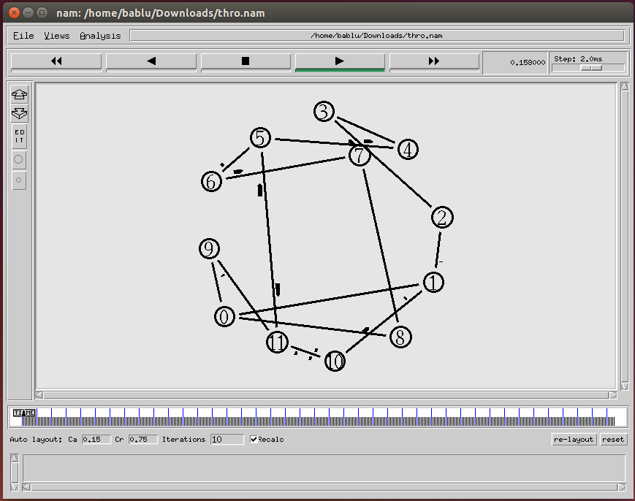

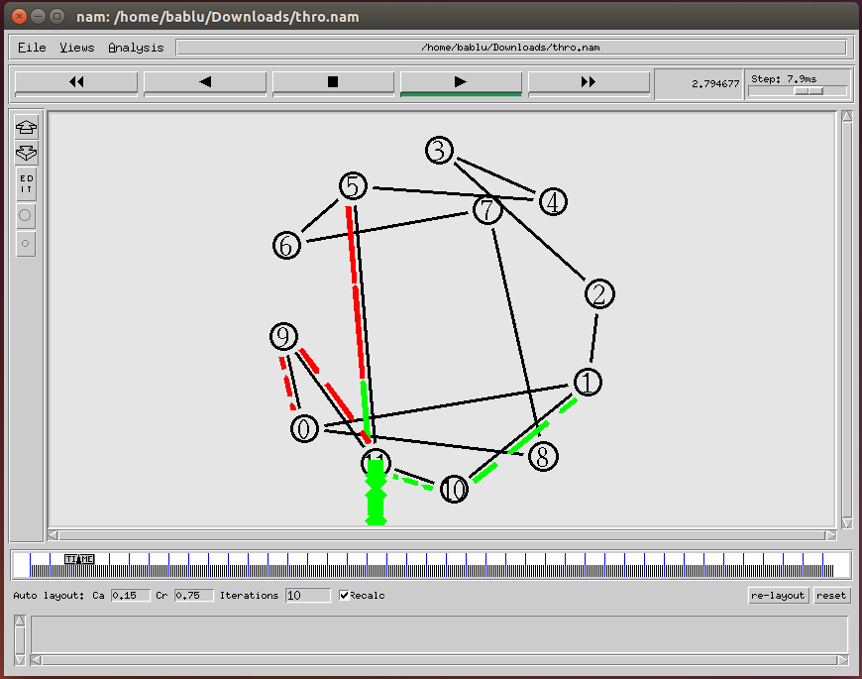

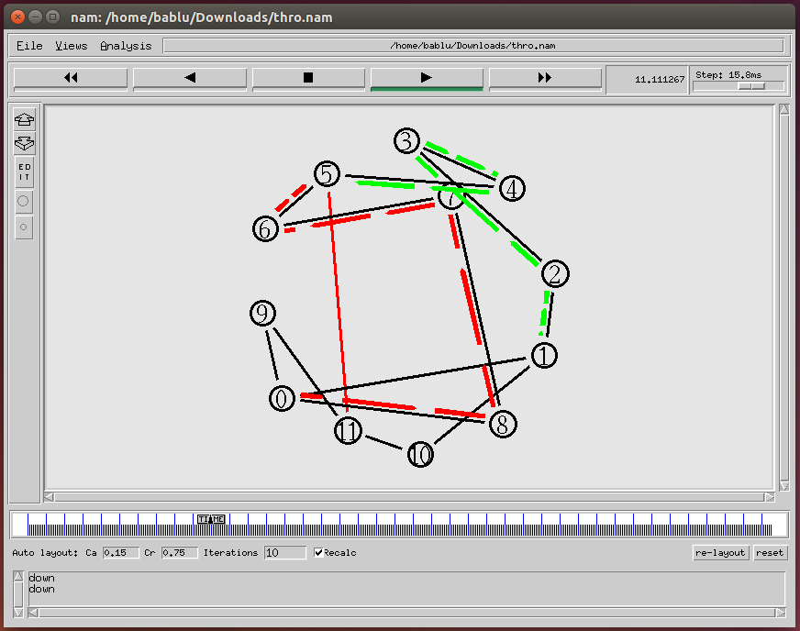

**RESULT:**

Thus the simulation of link state routing algorithm using ns2 has been executed successfully and output got verified.

|  |  |
| --- | --- |
| **EX.NO: 9** | **Performance Evaluation of Routing Protocols** |
| **DATE:** |

# AIM:

To Study of performance evaluation of routing protocols using simulation tool.

# ROUTING PROTOCOLS

There are many routing protocols available. Among them all we are working with AODV and DSR for performance analysis.

1. **Ad-hoc On demand Distance Vector (AODV)**

It is purely On-Demand route acquisition routing protocol. It is better protocol than DSDV network as the size of network may increase depending on the number of vehicle nodes.

* 1. **Path Discovery Process:**

In order to discover the path between source and destination, a Route Request message (RREQ) is broadcasted to all the neighbours in radio range who again continue to send the same to their neighbours in there radio range, until the destination is reached. Every node maintains two counters: sequence number and broadcast-id in order to maintain loop-free and most recent route information. The broadcast-id is incremented for every RREQ the source node initiates. If an intermediate node receives the same copy of request, it discards it without routing it further. When a node forwards the RREQ message, it records the address of the neighbour from which it received the first copy of the broadcast packet, in order to maintain a reverse path to the source node. The RREQ packet contains: the source sequence number and the last destination sequence number know to the source. The source sequence number is used to maintain information about reverse route and destination sequence number tells about the actual distance to the final node.

* 1. **Route Maintenance:**

A source node sends a new moving request packet RREQ to find a new route to the destination. But, if an intermediate node moves from its place, its upstream neighbor noticed the move and sends a message notification failure of the link to each of its active upstream neighbors to inform them about the move to source nodes is achieved. After the detection process is again initiated.

1. **Dynamic Source Routing (DSR)**

It is an On-Demand routing protocol in which the sequence of nodes through which a packet needs to travel is calculated and maintained as an information in packet header. Every mobile node in the network needs to maintain a route cache where it caches source routes that it has learned. When a packet is sent, the route- cache inside the node is compared with the actual route needs to be covered.

* 1. **Route Discovery:**

The source node broadcasts request-packets to all the neighbours in the network containing the address of the destination node, and a reply is sent back to the source node with the list of network-nodes through which it should propagate in the process. Sender initiates the route record as a list with a single element containing itself followed by the linking of its neighbour in that route. A request packet also contains an identification number called request-id, which is counter increased only when a new route request packet is being sent by the source node. To make sure that no loops occur during broadcast, the request is processed in the given order. A route reply is obtained in DSR by two ways: Symmetric-links (bidirectional), in which the backward route is followed again to catch the source node. Asymmetric-links (unidirectional) needs to discover the route up to the source node in the same manner as the forward route is discovered.

* 1. **Route Maintenance:**

In the hop by hop acknowledgement at data link layer allows the early detection and retransmission of lost or corrupt packets in the data-link layer. If a transmission error occurs, a route error packet containing the address of node detecting the error and the host address is sent back to the sender. Whenever a node receives a route error packet, the hop in error is removed from the route cache and all routes containing this hop are truncated at that point. When the wireless transmission between two nodes does not work equally well in both directions, and then end-to-end replies on the application or transport layer may be used to indicate the status of the route from one host to the other.

# RESULT:

Thus the performance evaluation of routing protocols was studied.

|  |  |
| --- | --- |
| **EX.NO: 10** | **Simulation of Error Correction Code (like CRC)** |
| **DATE:** |

# AIM:

To simulate the error correction code like CRC using java.

# THEORY:

**Cyclic redundancy check (CRC)**

* Unlike checksum scheme, which is based on addition, CRC is based on binary division.
* In CRC, a sequence of redundant bits, called cyclic redundancy check bits, are appended to the end of data unit so that the resulting data unit becomes exactly divisible by a second, predetermined binary number.
* At the destination, the incoming data unit is divided by the same number. If at this step there is no remainder, the data unit is assumed to be correct and is therefore accepted.
* A remainder indicates that the data unit has been damaged in transit and therefore must be rejected.

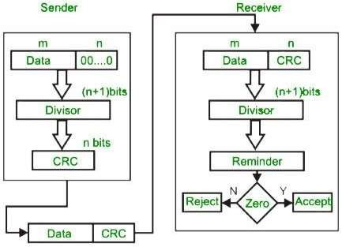

# EXAMPLE :

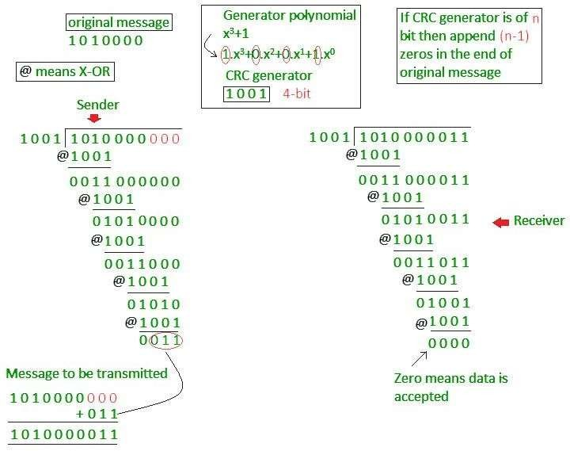

91

# ALGORITHM:

**Step 1:** Open the editor and type the program for error detection

**Step 2:** Get the input in the form of bits.

**Step 3:** Append the redundancy bits.

**Step 4:** Divide the appended data using a divisor polynomial. **Step 5:** The resulting data should be transmitted to the receiver. **Step 6:** At the receiver the received data is entered.

**Step 7:** The same process is repeated at the receiver.

**Step 8:** If the remainder is zero there is no error otherwise there is some error in the received bits

**Step 9:** Run the program.

# PROGRAM:

import java.io.*; class CRC

{

public static void main(String args[]) throws IOException

{

BufferedReader br = new BufferedReader(new InputStreamReader(System.in));

System.out.println("Enter Generator:"); String gen = br.readLine(); System.out.println("Enter Data:"); String data = br.readLine();

String code = data;

while(code.length() < (data.length() + gen.length() - 1)) code = code + "0";

code = data + div(code,gen);

System.out.println("The transmitted Code Word is: " + code); System.out.println("Please enter the received Code Word: ");

92

String rec = br.readLine(); if(Integer.parseInt(div(rec,gen)) == 0)

System.out.println("The received code word contains no errors.");

else

}

System.out.println("The received code word contains errors.");

static String div(String num1,String num2)

{

int pointer = num2.length();

String result = num1.substring(0, pointer); String remainder = "";

for(int i = 0; i < num2.length(); i++)

{

if(result.charAt(i) == num2.charAt(i)) remainder += "0";

else

}

remainder += "1"

while(pointer < num1.length())

{

if(remainder.charAt(0) == '0')

{

remainder = remainder.substring(1, remainder.length()); remainder = remainder +

String.valueOf(num1.charAt(pointer));

pointer++;

93

}

result = remainder; remainder = "";

for(int i = 0; i < num2.length(); i++)

{

if(result.charAt(i) == num2.charAt(i)) remainder += "0";

else

}

}

remainder += "1";

return remainder.substring(1,remainder.length());

}

}

94

# OUTPUT:

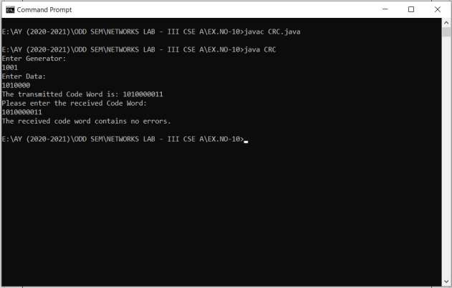

**RESULT:**

Thus the simulation of error correction code (like CRC) has been executed successfully and output got verified.

95

|  |  |
| --- | --- |
| **EX.NO: 11** | **Simulation of Go Back N protocol** |
| **DATE:** |

# AIM:

To Simulate and to study of Go Back N protocol.

# THEORY:

Go Back N is a connection oriented transmission. The sender transmits the frames continuously. Each frame in the buffer has a sequence number starting from 1 and increasing up to the window size. The sender has a window i.e. a buffer to store the frames. This buffer size is the number of frames to be transmitted continuously. The size of the window depends on the protocol designer.

# OPERATIONS:

1. A station may send multiple frames as allowed by the window size.
2. Receiver sends an ACK i if frame i has an error. After that, the receiver discards all incoming frames until the frame with error is correctly retransmitted.
3. If sender receives an ACK i it will retransmit frame i and all packets i+1, i+2,... which have been sent, but not been acknowledged

# ALGORITHM:

1. The source node transmits the frames continuously.
2. Each frame in the buffer has a sequence number starting from 1 and increasing up to the window size.
3. The source node has a window i.e. a buffer to store the frames. This buffer size is the number of frames to be transmitted continuously.
4. The size of the window depends on the protocol designer.
5. For the first frame, the receiving node forms a positive acknowledgement if the frame is received without error.
6. If subsequent frames are received without error (up to window size) cumulative positive acknowledgement is formed.
7. If the subsequent frame is received with error, the cumulative acknowledgment error-free frames are transmitted. If in the same window two frames or more frames are received with error, the second and the subsequent error frames are neglected.

96

Similarly even the frames received without error after the receipt of a frame with error are neglected.

1. The source node retransmits all frames of window from the first error frame.
2. If the frames are errorless in the next transmission and if the acknowledgment is error free, the window slides by the number of error-free frames being transmitted.
3. If the acknowledgment is transmitted with error, all the frames of window at source are retransmitted, and window doesn’t slide.
4. This concept of repeating the transmission from the first error frame in the window is called as GOBACKN transmission flow control protocol

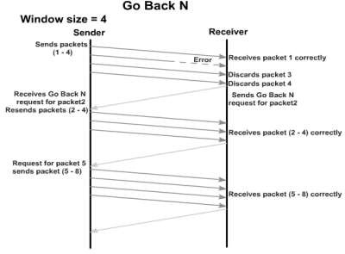

# PROGRAM:

#send packets one by one set ns [new Simulator] set n0 [$ns node]

set n1 [$ns node] set n2 [$ns node] set n3 [$ns node] set n4 [$ns node] set n5 [$ns node]

$n0 color "purple"

$n1 color "purple"

$n2 color "violet"

$n3 color "violet"

$n4 color "chocolate"

$n5 color "chocolate"

$n0 shape box ;

$n1 shape box ;

$n2 shape box ;

$n3 shape box ;

$n4 shape box ;

$n5 shape box ;

97

$ns at 0.0 "$n0 label SYS0"

$ns at 0.0 "$n1 label SYS1"

$ns at 0.0 "$n2 label SYS2"

$ns at 0.0 "$n3 label SYS3"

$ns at 0.0 "$n4 label SYS4"

$ns at 0.0 "$n5 label SYS5" set nf [open goback.nam w]

$ns namtrace-all $nf set f [open goback.tr w]

$ns trace-all $f

$ns duplex-link $n0 $n2 1Mb 20ms DropTail

$ns duplex-link-op $n0 $n2 orient right-down

$ns queue-limit $n0 $n2 5

$ns duplex-link $n1 $n2 1Mb 20ms DropTail

$ns duplex-link-op $n1 $n2 orient right-up

$ns duplex-link $n2 $n3 1Mb 20ms DropTail

$ns duplex-link-op $n2 $n3 orient right

$ns duplex-link $n3 $n4 1Mb 20ms DropTail

$ns duplex-link-op $n3 $n4 orient right-up

$ns duplex-link $n3 $n5 1Mb 20ms DropTail

$ns duplex-link-op $n3 $n5 orient right-down Agent/TCP set_nam_tracevar_true

set tcp [new Agent/TCP]

$tcp set fid 1

$ns attach-agent $n1 $tcp

set sink [new Agent/TCPSink]

$ns attach-agent $n4 $sink

$ns connect $tcp $sink

set ftp [new Application/FTP]

$ftp attach-agent $tcp

$ns at 0.05 "$ftp start"

$ns at 0.06 "$tcp set windowlnit 6"

$ns at 0.06 "$tcp set maxcwnd 6"

$ns at 0.25 "$ns queue-limit $n3 $n4 0"

$ns at 0.26 "$ns queue-limit $n3 $n4 10"

$ns at 0.305 "$tcp set windowlnit 4"

$ns at 0.305 "$tcp set maxcwnd 4"

$ns at 0.368 "$ns detach-agent $n1 $tcp ; $ns detach-agent $n4 $sink"

$ns at 1.5 "finish"

$ns at 0.0 "$ns trace-annotate \"Goback N end\""

$ns at 0.05 "$ns trace-annotate \"FTP starts at 0.01\""

$ns at 0.06 "$ns trace-annotate \"Send 6Packets from SYS1 to SYS4\""

$ns at 0.26 "$ns trace-annotate \"Error Occurs for 4th packet so not sent ack for the Packet\""

$ns at 0.30 "$ns trace-annotate \"Retransmit Packet_4 to 6\""

$ns at 1.0 "$ns trace-annotate \"FTP stops\"" proc finish {} {

98

global ns nf

$ns flush-trace close $nf

puts "filtering..."

#exec tclsh../bin/namfilter.tcl goback.nam #puts "running nam..."

exec nam goback.nam & exit 0

}

$ns run

# OUTPUT:

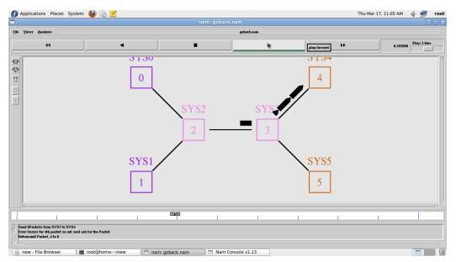

**RESULT:**

Thus the Go Back N protocol is simulated and studied.

99

|  |  |
| --- | --- |
| **EX.NO: 12** | **Simulation of selective repeat ARQ protocol** |
| **DATE:** |

# AIM:

To Simulate and to study of selective repeat ARQ protocol.

# THEORY:

Selective Repeat ARQ is a specific instance of the Automatic Repeat-reQuest (ARQ) Protocol. It may be used as a protocol for the delivery and acknowledgement of message units, or it may be used as a protocol for the delivery of subdivided message sub-units. When used as the protocol for the delivery of messages, the sending process continues to send a number of frames specified by a window size even after a frame loss. Unlike GoBack-N ARQ, the receiving process will continue to accept and acknowledge frames sent after an initial error. The receiver process keeps track of the sequence number of the earliest frame it has not received, and sends that number with every ACK it sends. If a frame from the sender does not reach the receiver, the sender continues to send subsequent frames until it has emptied its window. The receiver continues to fill its receiving window with the subsequent frames, replying each time with an ACK containing the sequence number of the earliest missing frame. Once the sender has sent all the frames in its window, it re-sends the frame number given by the ACKs, and then continues where it left off. The size of the sending and receiving windows must be equal, and half the maximum sequence number (assuming that sequence numbers are numbered from 0 to n-1) to avoid miscommunication in all cases of packets being dropped. To understand this, consider the case when all ACKs are destroyed. If the receiving window is larger than half the maximum sequence number, some, possibly even all, of the packages that are resent after timeouts are duplicates that are not recognized as such. The sender moves its window for every packet that is acknowledged.

100

Advantage over Go Back N:

1. Fewer retransmissions.

Disadvantages:

1. More complexity at sender and receiver
2. Receiver may receive frames out of sequence

# ALGORITHM:

1. The source node transmits the frames continuously.
2. Each frame in the buffer has a sequence number starting from 1 and increasing up to the window size.
3. The source node has a window i.e. a buffer to store the frames. This buffer size is the number of frames to be transmitted continuously.
4. The receiver has a buffer to store the received frames. The size of the buffer depends upon the window size defined by the protocol designer.
5. The size of the window depends according to the protocol designer.
6. The source node transmits frames continuously till the window size is exhausted. If any of the frames are received with error only those frames are requested for retransmission (with a negative acknowledgement)
7. If all the frames are received without error, a cumulative positive acknowledgement is sent.
8. If there is an error in frame 3, an acknowledgement for the frame 2 is sent and then only Frame 3 is retransmitted. Now the window slides to get the next frames to the window.
9. If acknowledgment is transmitted with error, all the frames of window are retransmitted. Else ordinary window sliding takes place. (* In implementation part, Acknowledgment error is not considered)
10. If all the frames transmitted are errorless the next transmission is carried out for the new window.
11. This concept of repeating the transmission for the error frames only is called Selective Repeat transmission flow control protocol.

101

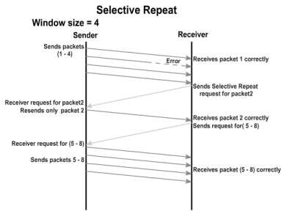

# PROGRAM:

#send packets one by one set ns [new Simulator] set n0 [$ns node]

set n1 [$ns node] set n2 [$ns node] set n3 [$ns node] set n4 [$ns node] set n5 [$ns node]

$n0 color "red"

$n1 color "red"

$n2 color "green"

$n3 color "green"

$n4 color "black"

$n5 color "black"

$n0 shape circle ;

$n1 shape circle ;

$n2 shape circle ;

$n3 shape circle ;

$n4 shape circle ;

$n5 shape circle ;

$ns at 0.0 "$n0 label SYS1"

$ns at 0.0 "$n1 label SYS2"

$ns at 0.0 "$n2 label SYS3"

$ns at 0.0 "$n3 label SYS4"

$ns at 0.0 "$n4 label SYS5"

$ns at 0.0 "$n5 label SYS6" set nf [open Srepeat.nam w]

$ns namtrace-all $nf

set f [open Srepeat.tr w]

$ns trace-all $f

$ns duplex-link $n0 $n2 1Mb 10ms DropTail

102

$ns duplex-link-op $n0 $n2 orient right-down

$ns queue-limit $n0 $n2 5

$ns duplex-link $n1 $n2 1Mb 10ms DropTail

$ns duplex-link-op $n1 $n2 orient right-up

$ns duplex-link $n2 $n3 1Mb 10ms DropTail

$ns duplex-link-op $n2 $n3 orient right

$ns duplex-link $n3 $n4 1Mb 10ms DropTail

$ns duplex-link-op $n3 $n4 orient right-up

$ns duplex-link $n3 $n5 1Mb 10ms DropTail

$ns duplex-link-op $n3 $n5 orient right-down Agent/TCP set_nam_tracevar_true

set tcp [new Agent/TCP]

$tcp set fid 1

$ns attach-agent $n1 $tcp

set sink [new Agent/TCPSink]

$ns attach-agent $n4 $sink

$ns connect $tcp $sink

set ftp [new Application/FTP]

$ftp attach-agent $tcp

$ns at 0.05 "$ftp start"

$ns at 0.06 "$tcp set windowlnit 8"

$ns at 0.06 "$tcp set maxcwnd 8"

$ns at 0.25 "$ns queue-limit $n3 $n4 0"

$ns at 0.26 "$ns queue-limit $n3 $n4 10"

$ns at 0.30 "$tcp set windowlnit 1"

$ns at 0.30 "$tcp set maxcwnd 1"

$ns at 0.30 "$ns queue-limit $n3 $n4 10**"**

$ns at 0.47 "$ns detach-agent $n1 $tcp;$ns detach-agent $n4 $sink"

$ns at 1.75 "finish"

$ns at 0.0 "$ns trace-annotate \"Select and repeat\""

$ns at 0.05 "$ns trace-annotate \"FTP starts at 0.01\""

$ns at 0.06 "$ns trace-annotate \"Send 8Packets from SYS1 to SYS4\""

$ns at 0.26 "$ns trace-annotate \"Error Occurs in 4th packet \""

$ns at 0.30 "$ns trace-annotate \"Retransmit Packet_4 from SYS1 to SYS4\""

$ns at 1.5 "$ns trace-annotate \"FTP stops\"" proc finish {} {

global ns nf

$ns flush-trace close $nf

puts "filtering..."

#exec tclsh../bin/namfilter.tcl srepeat.nam #puts "running nam..."

exec nam Srepeat.nam & exit 0

}

$ns run

103

# OUTPUT:

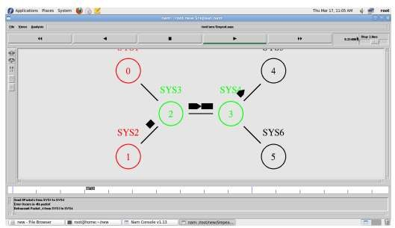

**RESULT:**

Thus the Selective Repeat Protocol is simulated and studied.

104